"Spancill Hill"
Last night as I lay dreaming of pleasant days gone by
My mind being bent on rambling to Ireland I did fly
I stepped on board a vision and followed with the wind
Till next I came to anchor at the cross near Spancill Hill
T'was on the 23rd June the day before the fair
When lreland's sons and daughters and friends assembled there
The young ,the old, the brave, the bold came their duty to fill
At the parish church at Cluney just a mile from Spancill Hill
I went to see my neighbors to hear what they might say
The old ones were all dead and gone the young one's turning grey
I met the tailor Quigley, he's bold as ever still
Sure he used to mend my britches when I lived at Spancill Hill
I paid a flying visit to my first and only love
She's fair as any lily and gentle as a dove
She threw her arms around me saying "Johnny I love you still"
She was Meg the farmers daughter and the pride of Spancill Hill
She was Meg the farmers daughter and the pride of Spancill Hill

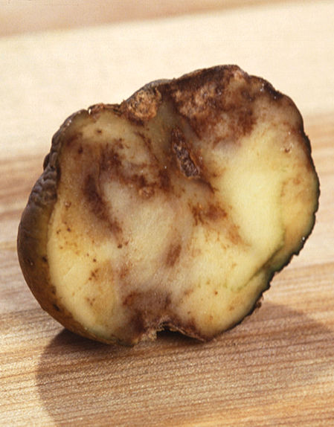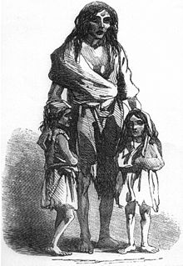
Blighted potato Victims of the Great Famine

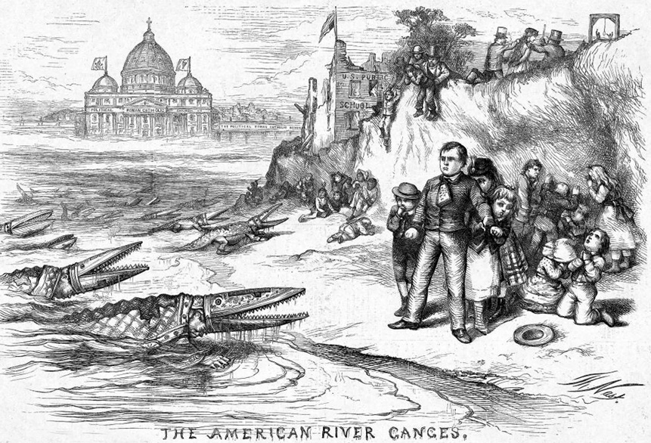
Thomas Nast Cartoon on immigration

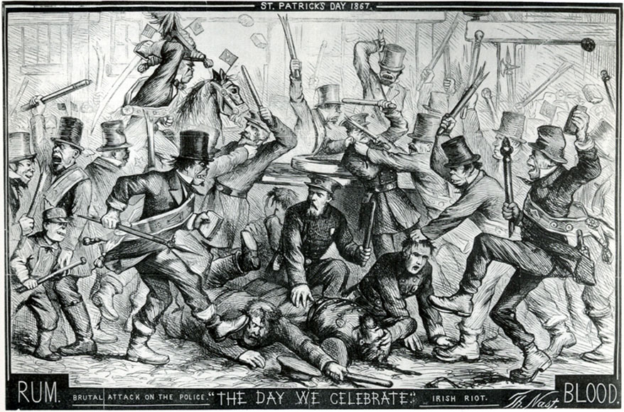
Thomas Nast Cartoon: Irish Mob Rule

