Roundtable Discussion
Debating Union & Secession

Use everything you have learned in class thus far, plus the documents below, to address the following questions:
- What were the causes of the Civil War?
- Why did Southern states secede?
- What arguments did unionists and secessionists put forward? In the north? In the south? In the west?
- In your opinion, did any state have a right to leave the Union?
- In your opinion, was Lincoln right to use military force to keep the Union intact?

To support your answers, cite specific historical events, concepts and documents in your response, paying particularly close attention to Documents C & E.

Document A
Electoral College Results, 1860  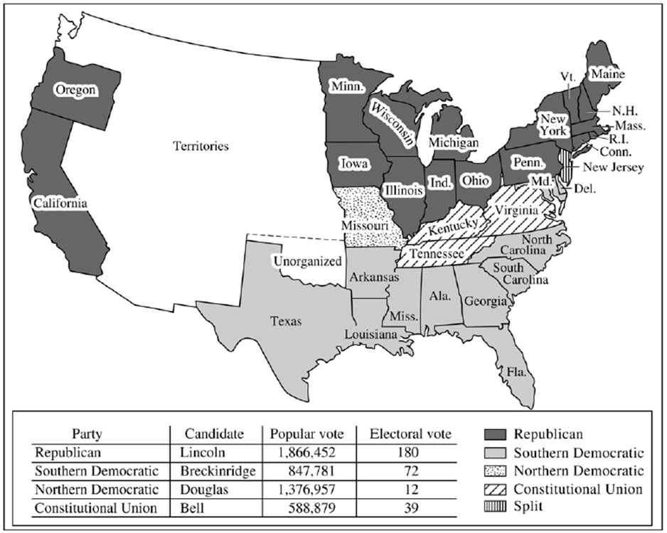 | Your Summary & Interpretation

Document B
James Buchanan  Fourth Annual Message to Congress  December 3, 1860  All for which the slave States have ever contended, is to be let alone and permitted to manage their domestic institutions in their own way. As sovereign States, they, and they alone, are responsible before God and the world for the slavery existing among them…  The Southern States, standing on the basis of the Constitution, have a right to demand this act of justice from the States of the North. Should it be refused, then the Constitution, to which all the States are parties, will have been willfully violated by one portion of them in a provision essential to the domestic security and happiness of the remainder. In that event the injured States, after having first used all peaceful and constitutional means to obtain redress, would be justified in revolutionary resistance to the Government of the Union…  Congress can contribute much to avert [Southern withdrawal from the Union] by proposing and recommending to the legislatures of the several States the remedy for existing evils which the Constitution has itself provided for its own preservation,… an “explanatory amendment” of the Constitution on the subject of slavery…  - An express recognition of the right of property in slaves in the States where it now exists or may hereafter exist.  - The duty of protecting this right in all the common Territories…  - A like recognition of the right of the master to have his slave who has escaped from one State to another restored… | Your Summary & Interpretation

*Document C*
Declaration of the Immediate Causes Which Induce and Justify the Secession of South Carolina from the Federal Union [South Carolina Declaration of Causes]  December 24, 1860  [Paragraphs 1-2]  The people of the State of South Carolina, in Convention assembled, on the 26th day of April, A.D., 1852, declared that the frequent violations of the Constitution of the United States, by the Federal Government, and its encroachments upon the reserved rights of the States, fully justified this State in then withdrawing from the Federal Union; but in deference to the opinions and wishes of the other slaveholding States, she forbore at that time to exercise this right. Since that time, these encroachments have continued to increase, and further forbearance ceases to be a virtue.  And now the State of South Carolina having resumed her separate and equal place among nations, deems it due to herself, to the remaining United States of America, and to the nations of the world, that she should declare the immediate causes which have led to this act.  [Paragraphs 3-8]  In the year 1765, that portion of the British Empire embracing Great Britain, undertook to make laws for the government of that portion composed of the thirteen American Colonies. A struggle for the right of self-government ensued, which resulted, on the 4th of July, 1776, in a Declaration [of Independence]…  In pursuance of this Declaration of Independence, each of the thirteen States proceeded to exercise its separate sovereignty; adopted for itself a Constitution… For purposes of defense… they entered into a League known as the Articles of Confederation…  In 1787, Deputies were appointed by the States to revise the Articles of Confederation, and… recommended for the adoption… of the Constitution of the United States…  By this Constitution, certain duties were imposed upon the several States, and the exercise of certain of their powers was restrained, which necessarily implied their continued existence as sovereign States. But to remove all doubt, an amendment was added, which declared that the powers not delegated to the United States by the Constitution, nor prohibited by it to the States, are reserved to the States, respectively, or to the people…  We hold that the Government thus established is subject to the two great principles asserted in the Declaration of Independence; and we hold further, that the mode of its formation subjects it to a third fundamental principle, namely: the law of compact. We maintain that in every compact between two or more parties, the obligation is mutual; that the failure of one of the contracting parties to perform a material part of the agreement, entirely releases the obligation of the other; and that where no arbiter is provided, each party is remitted to his own judgment to determine the fact of failure, with all its consequences.  In the present case, that fact is established with certainty. We assert that fourteen of the States have deliberately refused, for years past, to fulfill their constitutional obligations, and we refer to their own Statutes for the proof.  [Paragraphs 9-13]  The Constitution of the United States, in its fourth Article, provides as follows: “No person held to service or labor in one State, under the laws thereof, escaping into another, shall, in consequence of any law or regulation therein, be discharged from such service or labor, but shall be delivered up, on claim of the party to whom such service or labor may be due…”  The same article of the Constitution stipulates also for rendition by the several States of fugitives from justice from the other States.  The General Government, as the common agent, passed laws to carry into effect these stipulations of the States. For many years these laws were executed. But an increasing hostility on the part of the non-slaveholding States to the institution of slavery, has led to a disregard of their obligations, and the laws of the General Government have ceased to effect the objects of the Constitution. The States of Maine, New Hampshire, Vermont, Massachusetts, Connecticut, Rhode Island, New York, Pennsylvania, Illinois, Indiana, Michigan, Wisconsin and Iowa, have enacted laws which either nullify the Acts of Congress or render useless any attempt to execute them…  Those States have assumed the right of deciding upon the propriety of our domestic institutions; and have denied the rights of property established in fifteen of the States and recognized by the Constitution; they have denounced as sinful the institution of slavery; they have permitted open establishment among them of societies, whose avowed object is to disturb the peace and to eloign the property of the citizens of other States. They have encouraged and assisted thousands of our slaves to leave their homes; and those who remain, have been incited by emissaries, books and pictures to servile insurrection.  For twenty-five years this agitation has been steadily increasing, until it has now secured to its aid the power of the common Government. Observing the forms of the Constitution, a sectional party has found within that Article establishing the Executive Department, the means of subverting the Constitution itself. A geographical line has been drawn across the Union, and all the States north of that line have united in the election of a man to the high office of President of the United States, whose opinions and purposes are hostile to slavery. He is to be entrusted with the administration of the common Government, because he has declared that that “Government cannot endure permanently half slave, half free,” and that the public mind must rest in the belief that slavery is in the course of ultimate extinction…  We, therefore, the People of South Carolina, by our delegates in Convention assembled, appealing to the Supreme Judge of the world for the rectitude of our intentions, have solemnly declared that the Union heretofore existing between this State and the other States of North America, is dissolved, and that the State of South Carolina has resumed her position among the nations of the world, as a separate and independent State; with full power to levy war, conclude peace, contract alliances, establish commerce, and to do all other acts and things which independent States may of right do. | Questions by Paragraph  Paragraphs 1-2  What is the purpose of this document?  Paragraphs 3-8  Why do you think that South Carolina retraces U.S. history in this document? Do you agree with its characterization of American history?  Paragraphs 9-13  What specific grievances does South Carolina have against the northern states and the federal government? Do you agree that these grievances are just cause for secession?  Final Question  Some present-day sympathizers of the Confederacy argue that “the Civil War wasn’t about slavery, it was about states’ rights.” Assess the validity of this statement.

Document D
James L. Petigru  Former South Carolina Attorney General  1860  "South Carolina is too small for a republic and too large for an insane asylum." | Your Summary & Interpretation

*Document E*
Abraham Lincoln  First Inaugural Address  March 4, 1861  [Paragraphs 1-3]  …Apprehension seems to exist among the people of the Southern States that by the accession of a Republican Administration their property and their peace and personal security are to be endangered. There has never been any reasonable cause for such apprehension. Indeed, the most ample evidence to the contrary has all the while existed and been open to their inspection. It is found in nearly all the published speeches of him who now addresses you. I do but quote from one of those speeches when I declare that--  “I have no purpose, directly or indirectly, to interfere with the institution of slavery in the States where it exists. I believe I have no lawful right to do so, and I have no inclination to do so.”  Those who nominated and elected me did so with full knowledge that I had made this and many similar declarations and had never recanted them…  [Paragraph 4]  It is seventy-two years since the first inauguration of a President under our National Constitution. During that period fifteen different and greatly distinguished citizens have in succession administered the executive branch of the Government. They have conducted it through many perils, and generally with great success. Yet, with all this scope of precedent, I now enter upon the same task for the brief constitutional term of four years under great and peculiar difficulty. A disruption of the Federal Union, heretofore only menaced, is now formidably attempted.  [Paragraphs 5-14]  I hold that in contemplation of universal law and of the Constitution the Union of these States is perpetual. Perpetuity is implied, if not expressed, in the fundamental law of all national governments. It is safe to assert that no government proper ever had a provision in its organic law for its own termination. Continue to execute all the express provisions of our National Constitution, and the Union will endure forever, it being impossible to destroy it except by some action not provided for in the instrument itself.  Again: If the United States be not a government proper, but an association of States in the nature of contract merely, can it, as acontract, be peaceably unmade by less than all the parties who made it? One party to a contract may violate it--break it, so to speak--but does it not require all to lawfully rescind it?  Descending from these general principles, we find the proposition that in legal contemplation the Union is perpetual confirmed by the history of the Union itself. The Union is much older than the Constitution. It was formed, in fact, by the Articles of Association in 1774. It was matured and continued by the Declaration of Independence in 1776. It was further matured, and the faith of all the then thirteen States expressly plighted and engaged that it should be perpetual, by the Articles of Confederation in 1778. And finally, in 1787, one of the declared objects for ordaining and establishing the Constitution was "to form a more perfect Union."  But if destruction of the Union by one or by a part only of the States be lawfully possible, the Union is less perfect than before the Constitution, having lost the vital element of perpetuity.  It follows from these views that no State upon its own mere motion can lawfully get out of the Union; that resolves and ordinances to that effect are legally void, and that acts of violence within any State or States against the authority of the United States are insurrectionary or revolutionary, according to circumstances.  I therefore consider that in view of the Constitution and the laws the Union is unbroken, and to the extent of my ability, I shall take care, as the Constitution itself expressly enjoins upon me, that the laws of the Union be faithfully executed in all the States…  In doing this there needs to be no bloodshed or violence, and there shall be none unless it be forced upon the national authority…  Plainly the central idea of secession is the essence of anarchy. A majority held in restraint by constitutional checks and limitations, and always changing easily with deliberate changes of popular opinions and sentiments, is the only true sovereign of a free people. Whoever rejects it does of necessity fly to anarchy or to despotism. Unanimity is impossible. The rule of a minority, as a permanent arrangement, is wholly inadmissible; so that, rejecting the majority principle, anarchy or despotism in some form is all that is left…  One section of our country believes slavery is right and ought to be extended, while the other believes it is wrong and ought not to be extended. This is the only substantial dispute. The fugitive- slave clause of the Constitution and the law for the suppression of the foreign slave trade are each as well enforced, perhaps, as any law can ever be..  Physically speaking, we can not separate. We can not remove our respective sections from each other nor build an impassable wall between them. A husband and wife may be divorced and go out of the presence and beyond the reach of each other, but the different parts of our country can not do this. They can not but remain face to face, and intercourse [trade], either amicable or hostile, must continue between them…  [Paragraph 15]  In your hands, my dissatisfied fellow-countrymen, and not in mine, is the momentous issue of civil war. The Government will not assail you. You can have no conflict without being yourselves the aggressors. You have no oath registered in heaven to destroy the Government, while I shall have the most solemn one to "preserve, protect, and defend it."  [Paragraph 16]  I am loath to close. We are not enemies, but friends. We must not be enemies. Though passion may have strained it must not break our bonds of affection. The mystic chords of memory, stretching from every battlefield and patriot grave to every living heart and hearthstone all over this broad land, will yet swell the chorus of the Union, when again touched, as surely they will be, by the better angels of our nature. | Questions by Paragraph  Paragraphs 1-3  What is Lincoln’s position on the abolition of slavery?  Paragraph 4  What new challenge does Lincoln face that his fifteen predecessors have not?  Paragraphs 5-14  How does Lincoln respond to arguments in favor of secession? (Be detailed in your response.) Do you agree with his views? Why or why not?  Paragraph 15  Summarize Lincoln’s statement here. Do you agree with him?  Paragraph 16  Summarize Lincoln’s statement here.

Document F
Bombardment of Fort Sumter  Currier & Ives  April 12, 1861  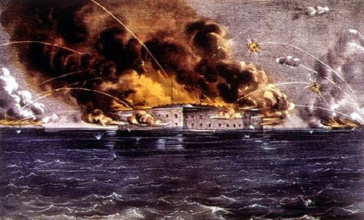 | Your Summary & Interpretation

Document G
Abraham Lincoln  Presidential Proclamation  April 15, 1861  Now, therefore, I, ABRAHAM LINCOLN, President of the United States, in virtue of the power in me vested by the Constitution and the laws, have thought fit to call forth, and hereby do call forth, the militia of the several States of the Union, to the aggregate number of seventy-five thousand, in order to suppress said combinations, and to cause the laws to be duly executed…  I appeal to all loyal citizens to favor, facilitate, and aid this effort to maintain the honor, the integrity, and the existence of our National Union, and the perpetuity of popular government; and to redress wrongs already long enough endured. I deem it proper to say that the first service assigned to the forces hereby called forth will probably be to repossess the forts, places, and property which have been seized from the Union… | Your Summary & Interpretation

Document H
Sam Houston  Former Governor of Texas  April 19, 1861  Let me tell you what is coming. After the sacrifice of countless millions of treasure and hundreds of thousands of lives, you may win Southern independence if God be not against you, but I doubt it. I tell you that, while I believe with you in the doctrine of states rights, the North is determined to preserve this Union. They are not a fiery, impulsive people as you are, for they live in colder climates. But when they begin to move in a given direction, they move with the steady momentum and perseverance of a mighty avalanche; and what I fear is, they will overwhelm the South. | Your Summary & Interpretation

