Omaha Platform, 1892

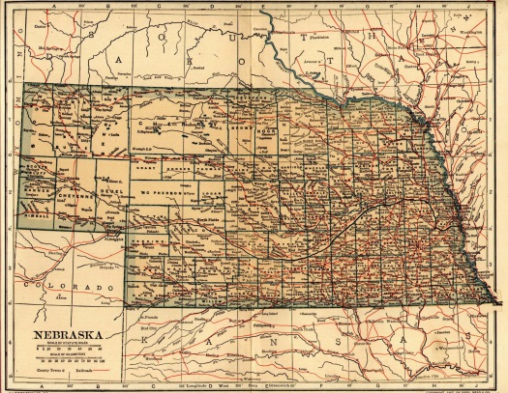

Influenced heavily by the Ocala Demands of 1890, the Populist Party platform adopted at the 1892 Omaha Convention called for a broad range of economic and political reforms. Place an “X” in the box below to indicate when, if at all, the goals of the Populist Party were accomplished.

Reform | Accomplished by Populists in  1890s | Accomplished by Progressives in 1900s-1910s | Accomplished by New Deal in 1930s | Failed
Abolition of the national bank
Abandonment of gold standard
Regulation of stock market
Restrictions on immigrant land ownership
Lower tariffs
Graduated income tax
Government regulation or nationalization of railroads, telegraphs & telephones
Direct election of senators
Eight-hour workday
Australian (secret) ballot
Initiatives
Referendums
Recall elections
One-term limit for president & vice president

