The Labor Movement,
1865-1914

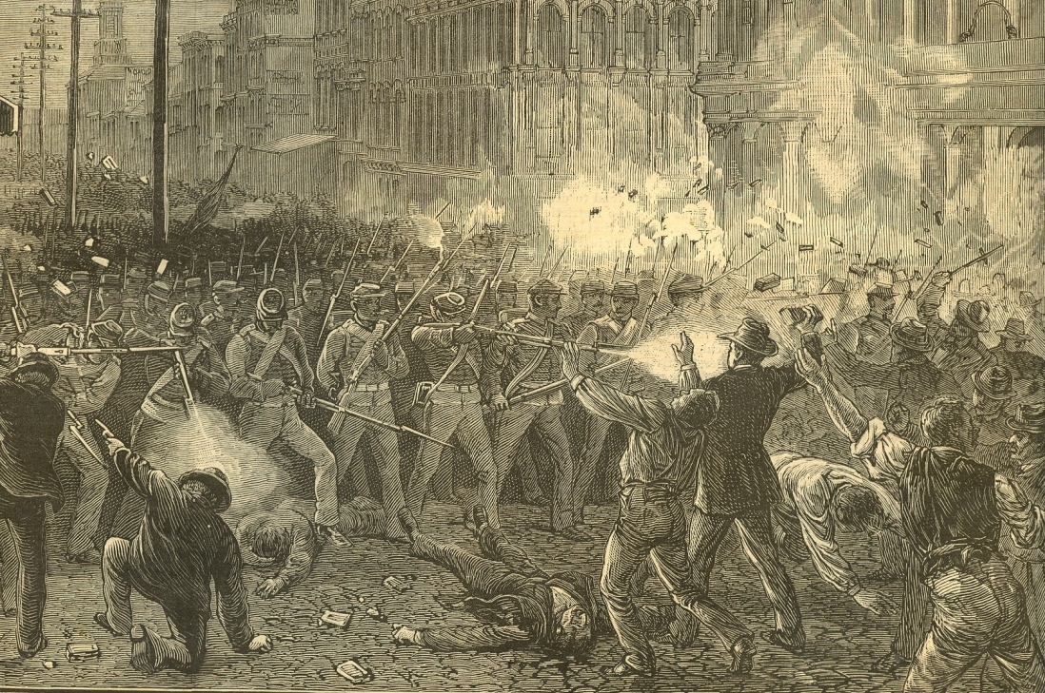

Labor Songs
“The (Lowell) Factory Girl”  Anonymous | “Solidarity Forever”  Written by Ralph Chaplin
“Casey Jones (The Union Scab)”  Written by Joe Hill | “Talking Union”  Written by Millard Lampell, Lee Hays & Pete Seeger

Conflicts Between Labor & Management
Labor Goals & Tactics | Middlemen | Mgmt. Goals & Tactics
- Higher wages, shorter hours & better working conditions  - “Eight-hour day” movement  - Organizing skilled workers vs. unskilled workers  - Organizing craft unions vs. trade unions  - Eliminate competition for jobs: nativist laws, child labor laws, closed shops  - Strikes & collective bargaining  - Closed shops | Mediators & arbitrators  Presidents  (Rutherford Hayes, Grover Cleveland, Theodore Roosevelt)  U.S. Supreme Court | - Yellow-dog contracts  - Lockouts  - Blacklists  - Pinkerton strike-breakers  - Race-baiting  - Hiring scabs  - Open shops  - Sherman Anti-Trust Act injunctions against unions

Key Labor Organizations
National Labor Union  (NLU)  1866-1874 | Knights of Labor  (K of L)  1869-1886
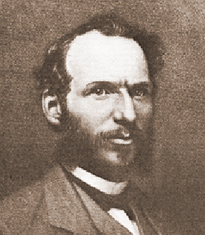 | 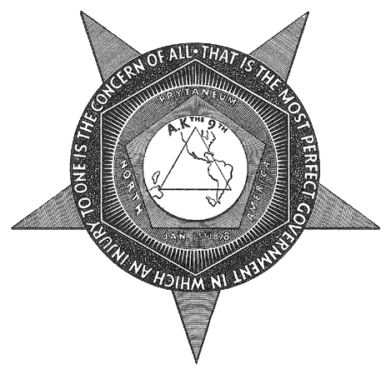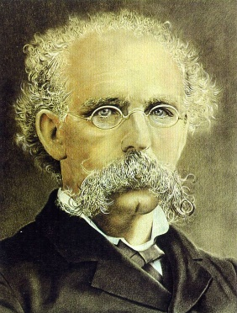
- Founded by William Sylvis  - First national labor union  - Launched eight-hour workday campaign  - Supported arbitration and political action over strikes  - Panic of 1873 ended NLU | - Founded by Terence V. Powderly  - Continued eight-hour workday campaign  - Organized skilled as well as unskilled workers, men and women, trade unions rather than craft unions  - Supported arbitration and political action, but later endorsed strikes  - Failed strikes and the Haymarket Riot led to its demise; it was replaced by the AFofL

American Federation of Labor  (AF of L)  1886-present | International Ladies Garment Workers Union  (ILGWU)  1900-1930s
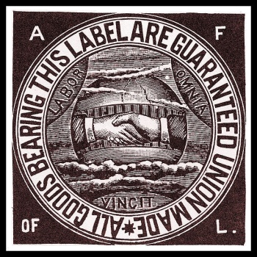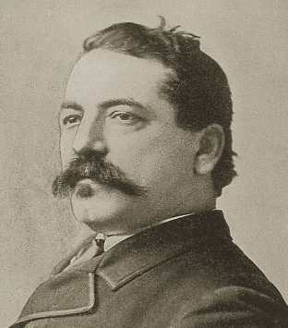 | 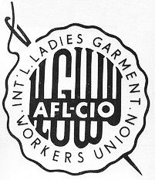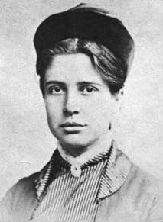
- Founded by Samuel Gompers  - Composed mostly of skilled workers who were not as easily replaced by scabs  - Organized craft unions and pushed for closed shops  - Endorsed strikes and supported strikers with a national strike fund paid by union dues  - Lobbied for passage of Chinese Exclusion Act and sometimes allowed segregated local unions  - Merged with the Congress of Industrial Organizations in 1955 to become the AFL-CIO | - Organized low-skilled female workers in the textile industry, including many immigrant workers  - After the Triangle Shirtwaist Factory Fire of 1911, the ILGWU lobbied successfully for government inspections of factories as well as laws requiring fire escapes and shorter work hours  - Florence Kelley, though not a member of the ILGWU, campaigned for special protections for female workers (Muller v. Oregon), and worked with Jane Addams’ settlement house movement.

Radical Labor
Socialists | Communists | Industrial Workers of the World (IWW)
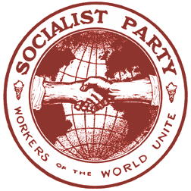 | 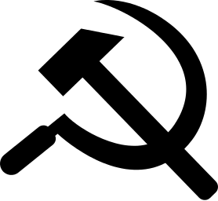 | 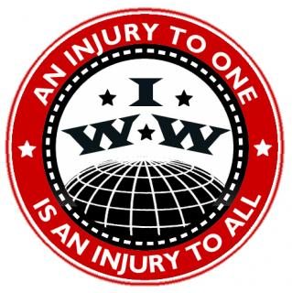
- Edward Bellamy’s novel Looking Backward (1888) imagined a future socialist utopia in the United States where all industry had been nationalized.  - Jack London’s novel The Iron Heel (1908) imagined a future dystopia in which industrial monopolists had established an oligarchy in the United States.  - Socialist Party candidates won some state and local offices  - Socialist Party candidate Eugene V. Debs campaigned for president five times from 1900-1920, winning 1-6% of the popular vote | 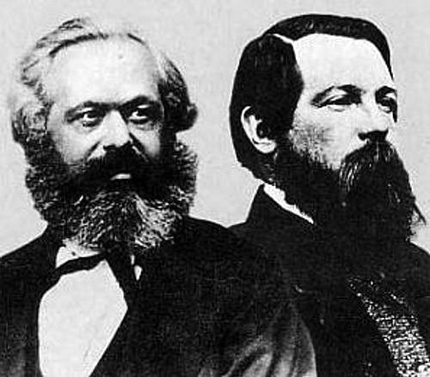  - Karl Marx & Friedrich Engels’ The Communist Manifesto (1848) and Das Kapital (1867) influenced the labor movement, even though most workers did not identify as communists  - The American Communist Party (CPUSA) was founded in 1919 and grew in influence during the Great Depression | - Nicknamed “Wobblies”  - Organized as an industrial union (“One Big Union”) rather than as a craft union  - Supported revolutionary “direct action” including strikes and sabotage  - Opposed nativism, racism, and sexism, and organized skilled as well as unskilled workers  - Internal conflicts, arrests of leaders, and competition from AF of L led to the IWW’s decline in the 1920s  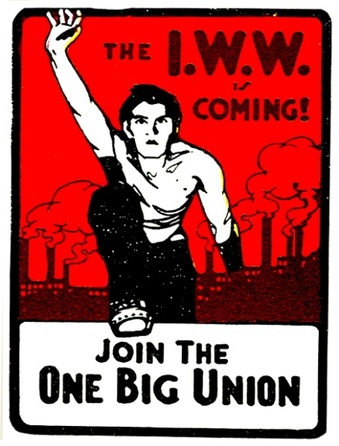

Major Events in Labor History
Event  (Year) | Key People & Orgs. | Causes & Early Events | Gov’t Response | Outcome  & Significance
Great Railroad Strike  (1877) | Workingmen’s Party; Rutherford Hayes | Panic of 1873; RR company paid dividends to investors while slashing workers’ pay; workers struck and rioted
Haymarket Affair  (1886) | Knights of Labor; anarchists; J.P. Altgeld | Workers at McCormick Reaper factory struck and held protests against police brutality
Homestead Strike  (1892) | Andrew Carnegie; Henry Clay Frick; Amalgamated Association of Iron and Steel Workers (AA) | Carnegie Steel locked out workers to force them to accept a paycut; Pinkertons and scabs were hired to crush strikers
Pullman Strike  (1894) | Eugene V. Debs; American Railway Union (ARU) | Pullman, IL was a “company town”; wages were slashed while rents stayed the same; workers struck
Coxey’s Army  (1894) | Jacob Coxey | Panic of 1893
Anthracite Coal Strike  (1902) | United Mine Workers (UMWA);  Teddy Roosevelt | UMWA struck, demanding higher wages, shorter hours and official recognition of their union
Triangle Shirtwaist Fire  (1911) | ILGWU; Florence Kelley | Doors were locked to keep workers from taking breaks; 146 workers died when a fire broke out
Ludlow Massacre (1914) | United Mine Workers (UMWA); John D. Rockefeller | UMWA struck in 1913; strike lasted into 1914
Questions
- Why did many unions fail in their goals in the short term?

- What were some important accomplishments of labor unions in the long term?

- Why did the AFofL enjoy more success and longevity than other unions?

“The Tournament of Today”
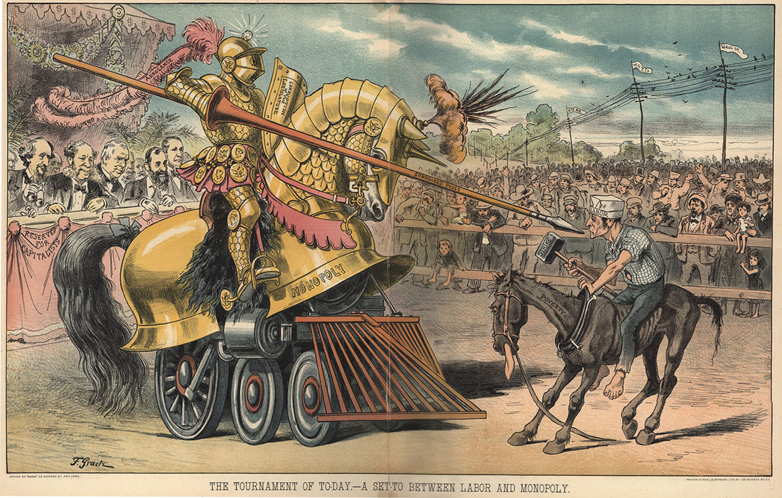
Write your interpretation of this political cartoon as it relates to the issue of labor unrest in the Gilded Age:

