North, South & West:

Documents on
Land & Slavery

Document 1

“Inspection and Sale of a Negro”
Date unknown

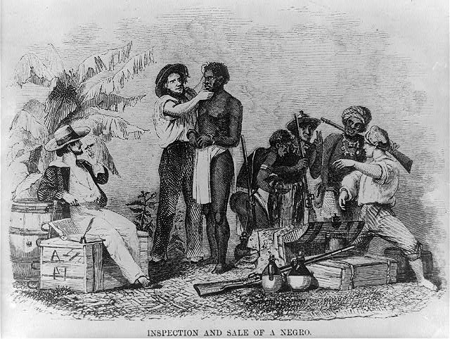

Document 2

Eli Whitney
Patent for the Cotton Gin
1794

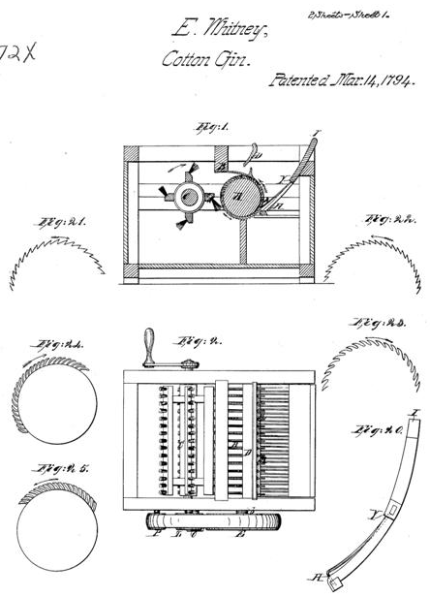
Document 3

Slave Importation Act
1807

Be it enacted by the Senate and House of Representatives of the United States of America in Congress assembled,

That from and after the first day of January, one thousand eight hundred and eight, it shall not be lawful to import or bring into the United States or the territories thereof from any foreign kingdom, place, or country, any negro, mulatto, or person of colour, with intent to hold, sell, or dispose of such negro, mulatto, or person of colour, as a slave, or to be held to service or labour.

Document 4
Map of the Territorial Expansion of the United States: 1803-1853
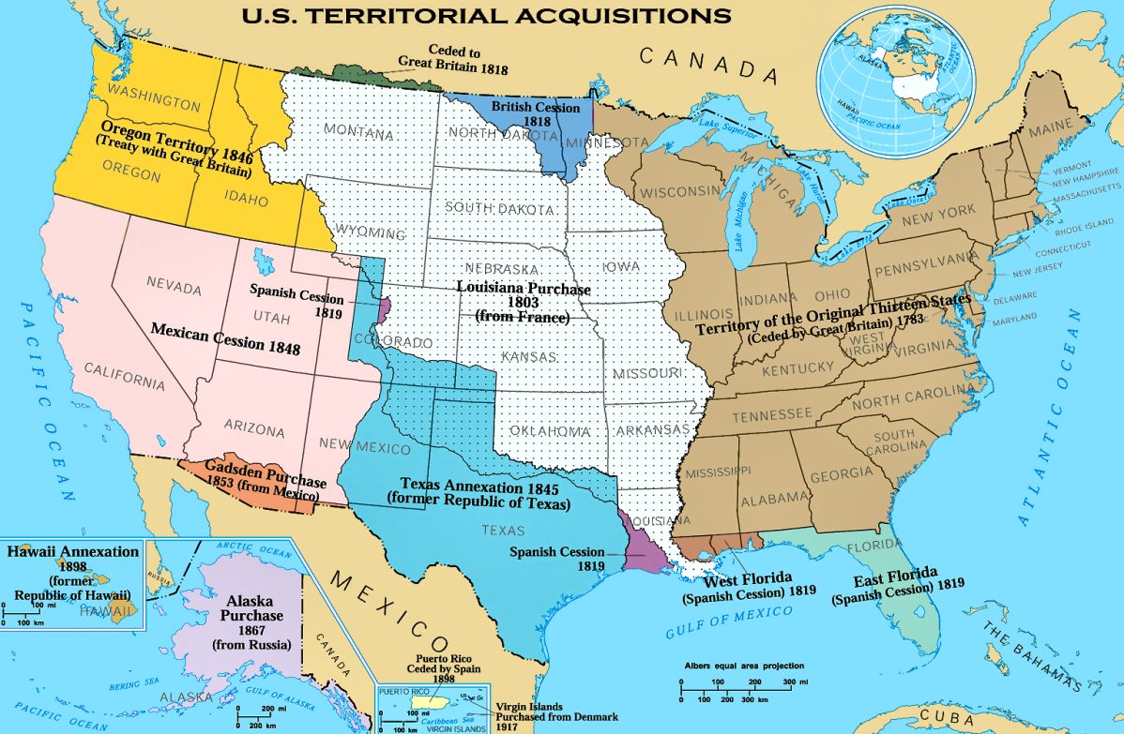
Document 5

Letter from Thomas Jefferson to John Holmes
April 22, 1820

I thank you, dear Sir, for the copy you have been so kind as to send me of the letter to your constituents on the Missouri question… But this momentous question, like a fire bell in the night, awakened and filled me with terror. I considered it at once as the knell of the Union. It is hushed, indeed, for the moment. But this is a reprieve only, not a final sentence. A geographical line, coinciding with a marked principle, moral and political, once conceived and held up to the angry passions of men, will never be obliterated; and every new irritation will mark it deeper and deeper… I regret that I am now to die in the belief, that the useless sacrifice of themselves by the generation of 1776, to acquire self-government and happiness to their country, is to be thrown away by the unwise and unworthy passions of their sons, and that my only consolation is to be, that I live not to weep over it.

Document 6

Opinion of Judge Thomas Ruffin, NC State Supreme Court
North Carolina v. Mann
1830

The indictment charges a battery on Lydia, a slave.… Upon the general question, whether the owner is answerable… for a battery upon his own slave, or other exercise of authority or force… the Court entertains but little doubt....

The power of the master must be absolute, to render the submission of the slave perfect. I most freely confess my sense of the harshness of this proposition, I feel it as deeply as any man can. And as a principle of moral right, every person in his retirement must repudiate it. But in the actual condition of things, it must be so. There is no remedy. This discipline belongs to the state of slavery. They cannot be disunited, without abrogating at once the rights of the master, and absolving the slave from his subjection. It constitutes the curse of slavery to both the bond and free portions of our population. But it is inherent in the relation of master and slave.
Document 7

Map of the Burned Over District and Protestant Revivals of the Early 1800s

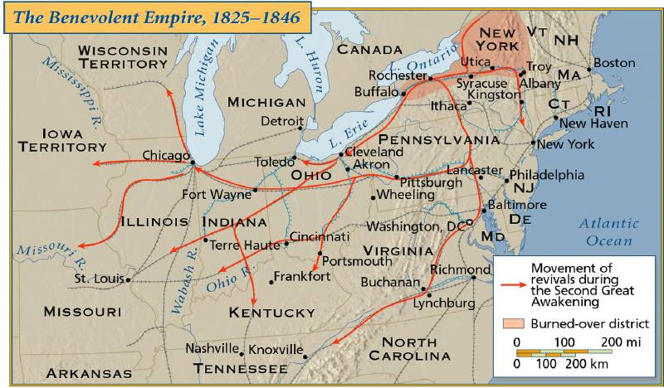
Document 8

David Walker
Walker’s Appeal in Four Articles
1830

…Mr. Jefferson's very severe remarks on us have been so extensively argued upon by men whose attainments in literature, I shall never be able to reach, that I would not have meddled with it, were it not to solicit each of my brethren, who has the spirit of a man, to buy a copy of Mr. Jefferson's “Notes on Virginia,” and put it in the hand of his son. For let no one of us suppose that the refutations which have been written by our white friends are enough--they are whites--we are blacks. We, and the world wish to see the charges of Mr. Jefferson refuted by the blacks themselves, according to their chance; for we must remember that what the whites have written respecting this subject, is other men's labours, and did not emanate from the blacks. I know well, that there are some talents and learning among the coloured people of this country, which we have not a chance to develope, in consequence of oppression; but our oppression ought not to hinder us from acquiring all we can. For we will have a chance to develope them by and by. God will not suffer us, always to be oppressed. Our sufferings will come to an end, in spite of all the Americans this side of eternity. Then we will want all the learning and talents among ourselves, and perhaps more, to govern ourselves.--"Every dog must have its day," the American's is coming to an end.

Document 9

The Confessions of Nat Turner, as Fully and Voluntarily Told to Thomas R. Gray
1831

On returning to the house, Hark went to the door with an axe, for the purpose of breaking it open, as we knew we were strong enough to murder the family, if they were awaked by the noise; but reflecting that it might create an alarm in the neighborhood, we determined to enter the house secretly, and murder them whilst sleeping. Hark got a ladder and set it against the chimney, on which I ascended, and hoisting a window, entered and came down stairs, unbarred the door and removed the guns from their places.

It was then observed that I must spill the first blood. On which, armed with a hatchet, and accompanied by Will, I entered my master's chamber, it being dark, I could not give a death blow, the hatchet glanced from his head, he sprang from the bed and called his wife, it was his last word, Will laid him dead, with a blow of his axe, and Mrs. Travis shared the same fate, as she lay in bed.

The murder of this family, five in number, was the work of a moment, not one of them awoke; there was a little infant sleeping in a cradle, that was forgotten, until we had left the house and gone some distance, when Henry and Will returned and killed it; we got here, four guns that would shoot, and several old muskets, with a pound or two of powder.

Document 10

Virginia Slave Code
1831

All meetings of free Negroes or mulattoes at any school house, church, meeting house or other place for teaching them reading or writing, either in the day or the night shall be considered an unlawful assembly. Warrants shall direct any sworn officer to enter and disperse such Negroes and inflict corporal punishment on the offenders at the discretion of the justice, not exceeding twenty lashes. Any white person assembling to instruct free Negroes to read or write shall be fined not over $50.00, also be imprisoned not exceeding two months.

It is further enacted that if any white person for pay shall assemble with any slaves for the purpose of teaching them to read or write, he shall for each offense be fined, at the discretion of the justice, $10.00-$100.00.

Document 11

William Lloyd Garrison
First issue of The Liberator
1831

“I do not wish to think, or speak, or write, with moderation. . . . I am in earnest -- I will not equivocate -- I will not excuse -- I will not retreat a single inch -- AND I WILL BE HEARD.”
Document 12

Engraving depicting events at the beginning of the Second Seminole War
1835

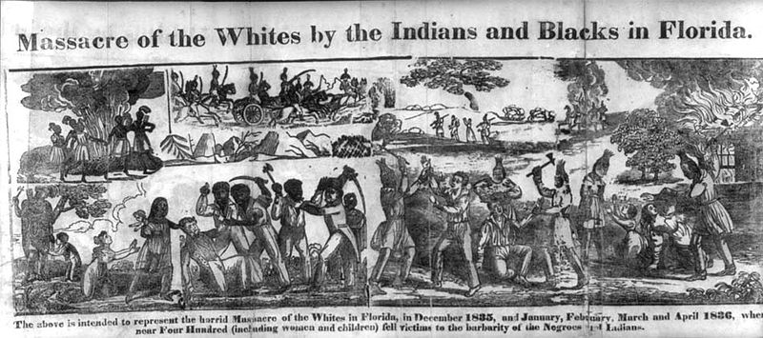
Document 13
Harper’s Weekly
“John Quincy Adams Pinned Down by the Gag Rule”
1839
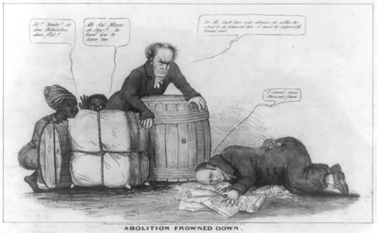

Document 14

Engraving depicting the Amistad Mutiny
1840

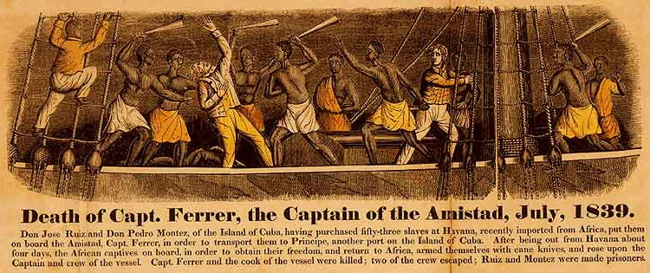
Document 15
American Colonization Society
Map of Liberia
1845
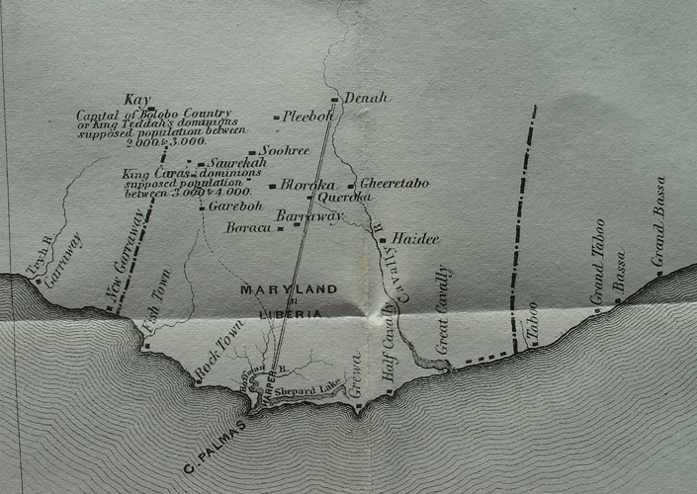

Document 16

John L. O’Sullivan
“On Manifest Destiny”
1845

It is now time for opposition to the annexation of Texas to end. It is time for the common duty of patriotism to the country to take over. If this duty is not recognized, it is at least time for common sense to give in to what is inevitable.

Texas is no longer to us a mere geographical place – a certain combination of coast, plain, mountain, valley, forest and stream. Patriotism, which is at once a sentiment and a virtue, already begins to thrill for it is within the national heart.

If we needed a reason for taking Texas into the Union, it surely is to be found in the manner in which other nations have interfered in the matter. Their object is to oppose our policy and check the fulfillment of our manifest destiny to spread over the continent. This we have seen done by England.

And [Texans] have a right to independence – to self-government, to possession of home conquered from the wilderness by their own labors and dangers, sufferings and sacrifices.

Document 17

David Wilmot
“Wilmot Proviso”
1847
There shall be neither slavery, nor involuntary servitude in any territory on the continent of America which shall hereafter be acquired by or annexed to the United States by virtue of this appropriation (the $3,000,000) or in any other manner whatever, except for a crime whereof the party shall have been duly convicted.

Document 18

Platform of the Free Soil Party
1848

2. Resolved, That slavery in the several states of this Union which recognize its existence depends upon the state law.-, alone, which cannot be repealed or modified by the federal government, and for which laws that government is not responsible. We therefore propose no interference by Congress with slavery within the limits of any state.

3. Resolved, That the proviso of Jefferson, to prohibit the existence of slavery after 1800 in all the territories of the United States, southern and northern; the votes of six states and sixteen delegates in the Congress of 1784 for the proviso, to three states and seven delegates against it; the actual exclusion of slavery from the Northwestern Territory, by the Ordinance of 1787, unanimously adopted by the states in Congress, and the entire history of that period,--clearly show that it was the settled policy of the nation not to extend, nationalize, or encourage, but to limit, localize, and discourage slavery; and to this policy, which should never have beef departed from, the government ought to return.
Document 19

Fugitive Slave Act
1850

Section 6: …That when a person held to service or labor in any state or territory of the United States, has heretofore or shall hereafter escape into another state or territory of the United States , the person or persons to who such service or labor may be due… may pursue and reclaim such fugitive person… In no trial or hearing under this act shall testimony of such alleged fugitive be admitted in evidence.

Section 7: …That any person who shall knowingly and willingly obstruct, hinder, or prevent such a claimant… from arresting such a fugitive from service or labor… or shall rescue or attempt to rescue such fugitive… or shall aid, abet, or assist such person so owing service or labor aforesaid, directly or indirectly, to escape from such claimant, or shall harbor or conceal such a fugitive, so as to prevent the discovery and arrest of such person… shall, for either of said offenses, be subject to a fine not exceeding one thousand dollars, and imprisonment not exceeding six months… and shall moreover forfeit and pay , by way of civil damages to the party injured by such illegal conduct, the sum of one thousand dollars, for each fugitive so lost.

Document 20

Henry Clay
“Speech on the Compromise of 1850”
February 6, 1850

It has been objected against this measure that it is a compromise. It has been said that it is a compromise of principle, or of a principle. Mr. President, what is a compromise? It is a work of mutual concession - an agreement in which there are reciprocal stipulations - a work in which, for the sake of peace and concord, one party abates his extreme demands in consideration of an abatement of extreme demands by the other party: it is a measure of mutual concession - a measure of mutual sacrifice…

I believe from the bottom of my soul that the measure is the reunion of this Union. I believe it is the dove of peace, which, taking its aerial flight from the dome of the Capitol, carries the glad tidings of assured peace and restored harmony to all the remotest extremities of this distracted land…

I call upon all the South. Sir, we have had hard words, bitter words, bitter thoughts, unpleasant feelings toward each other in the progress of this great measure. Let us forget them. Let us sacrifice these feelings. Let us go to the altar of our country and swear, as the oath was taken of old, that we will stand by her; that we will support her; that we will uphold her Constitution; that we will preserve her union; and that we will pass this great, comprehensive, and healing system of measures, which will hush all the jarring elements and bring peace and tranquillity to our homes…

[This] measure may be defeated. I have been aware that its passage for many days was not absolutely certain. ...But, if defeated, it will be a triumph of ultraism and impracticability-a triumph of a most extraordinary conjunction of extremes; a victory won by abolitionism; a victory achieved by freesoilism; a victory of discord and agitation over peace and tranquillity; and I pray to Almighty God that it may not, in consequence of the inauspicious result, lead to the most unhappy and disastrous consequences to our beloved country.

Document 21

Source unknown
“Slavery as it Exists in America; Slavery as it Exists in England”
1851

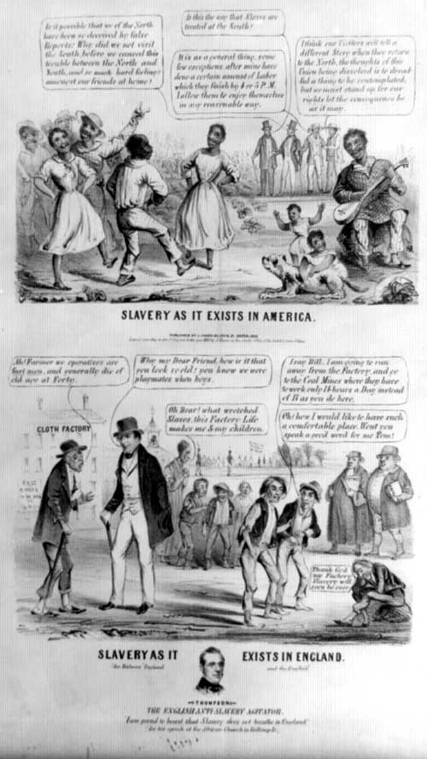
Document 22

Harriet Beecher Stowe
excerpt from Uncle Tom’s Cabin
1852

Susan and Emmeline were sent to the depot to await a general auction on the following morning; and as they glimmer faintly upon us in the moonlight which steals through the grated window, we may listen to their conversation. Both are weeping, but each quietly, that the other may not hear.

“Mother, just lay your head on my lap, and see if you can’t sleep a little,” says the girl, trying to appear calm.
“I haven’t any heart to sleep, Em; I can’t; it’s the last night we may be together!”

“Oh, mother, don’t say so! Perhaps we shall get sold together who knows?”

“If it was anybody else’s case, I should say so, too, Em,” said the woman; “But I’m so a-feared of losin’ you that I don’t see anything but the danger.”

“Why, mother, the man said we were both likely, and would sell well.”

Susan remembered the man’s looks and words. With a deadly sickness at her heart, she remembered how he had looked at Emmeline’s hands, and lifted up her curly hair, and pronounced her a first-rate article. Susan had been trained as a Christian, brought up in the daily reading of the Bible, and had the same horror of her child’s being sold to a life of shame that any other Christian mother might have; but she had no hope no protection.

“Mother, I think we might do first-rate, if you could get a place as a cook, and I as chambermaid or seamstress, in some family. I dare say we shall. Let’s both look as bright and lively as we can, and tell all we can do, and perhaps we shall,” said Emmeline.

“I want you to brush your hair all back straight, to-morrow,” said Susan.

“What for, mother? I don’t look near so well that way.”

“Yes, but you’ll sell better so.”

“I don’t see why!” said the child.

“Respectable families would be more apt to buy you, if they say you looked plain and decent, as if you wasn’t trying to look handsome. I know their ways better’n you do,” said Susan.

“Well, mother, then I will.”

“And Emmeline, if we shouldn’t ever see each other again, after tomorrow if I’m sold way up on a plantation somewhere, and you somewhere else, and you somewhere else always remember how you’ve been brought up, and all Missis has told you; take your Bible with you, and your hymnbook; and if you’re faithful to the Lord, he’ll be faithful to you.”

So speaks the poor soul, in sore discouragement; for she knows that tomorrow any man, however vile and brutal, however godless and merciless, if he only has money to pay for her, may become owner of her daughter, body and soul; and then, how is the child to be faithful? She thinks of all this, as she holds her daughter in her arms, and wishes that she were not handsome and attractive.

Document 23

“Follow the Drinking Gourd”
Traditional African American spiritual

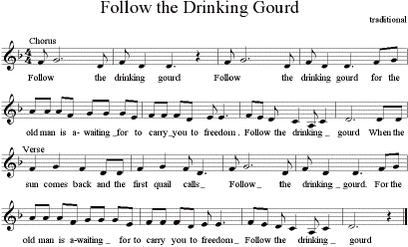
Document 24
Ostend Manifesto
1854

We have arrived at the conclusion, and are thoroughly convinced, that an immediate and earnest effort ought to be made by the government of the United States to purchase Cuba from Spain at any price for which it can be obtained…

We firmly believe that, in the progress of human events, the time has arrived when the vital interests of Spain are as seriously involved in the sale, as those of the United States in the purchase of the island, and that the transaction will prove equally honorable to both nations.

The intercourse which its proximity to our coasts begets and encourages between them and the citizens of the United States has, in the progress of time, so united their interests and blended their fortunes that they now look upon each other as if they were one people and had but one destiny… Its inhabitants are now suffering under the worst of all possible governments – that of absolute despotism delegated by a distant power to irresponsible agents, who are changed at short intervals, and who are tempted to improve the brief opportunity thus afforded to accumulate fortunes by the basest means.

We have already witnessed the happy results for both countries which followed a similar arrangement in regard to Florida.

Yours very respectfully,
James Buchanan
J. Y. Mason
Pierre Soulé

Document 25

George Fitzhugh
Sociology for the South
1854

[Firstly], a highly moral and intellectual people, like the free citizens of ancient Athens, are best governed by a democracy. For a less moral and intellectual one, a limited and constitutional monarchy will answer. For a people either very ignorant or very wicked, nothing short of military despotism will suffice… Now, it is clear the Athenian democracy would not suit a negro nation, nor will the government of mere law suffice for the individual negro. He is but a grown up child, and must be governed as a child, not as a lunatic or criminal. The master occupies towards him the place of parent or guardian…

Secondly, The negro is improvident; will not lay up in summer for the wants of winter; will not accumulate in youth for the exigencies of age. He would become an insufferable burden to society…

In the last place, the negro race is inferior to the white race, and living in their midst, they would be far outstripped or outwitted in the chase of free competition. Gradual but certain extermination would be their fate. We presume the maddest abolitionist does not think the negro's providence of habits and money-making capacity at all to compare to those of the whites. This defect of character would alone justify enslaving him, if he is to remain here. In Africa or the West Indies, he would become idolatrous, savage and cannibal, or be devoured by savages and cannibals. At the North he would freeze or starve.

“In the sweat of thy face shalt thou earn thy bread!” made all men slaves, and such all good men continue to be … [But w]hilst labor-saving processes have probably lessened by one half, in the last century, the amount of work needed for comfortable support the free laborer is compelled by capital and competition to work more than he ever did before, and is less comfortable. The organization of society cheats him of his earnings, and those earnings go to swell the vulgar pomp and pageantry of the ignorant millionaires… We need never have white slaves in the South, because we have black ones.

Every shade and variety of slavery has existed in the world. In some cases there has been much of legal regulation, much restraint of the master's authority; in others, none at all… We might and should have laws in Virginia, as in Louisiana, to make the master subject to presentment by the grand jury and to punishment, for any inhuman or improper treatment or neglect of his slave… The Southerner is the negro’s friend, his only friend. Let no intermeddling abolitionist, no refined philosophy, dissolve this friendship.

Document 26

Charles Sumner

“The Crime Against Kansas: The Apologies for the Crime; The True Remedy”

Delivered to the United States Senate, 19-20 May 1856
…[T]he Nebraska Bill was in every respect a swindle. It was a swindle of the North by the South. On the part of those who had already completely enjoyed their share of the Missouri Compromise, it was a swindle of those whose share was yet absolutely untouched; and the plea of unconstitutionality set up -- like the plea of usury after the borrowed money has been enjoyed -- did not make it less a swindle. Urged as a bill of peace, it was a swindle of the whole country. Urged as opening the doors to slave-masters with their slaves, it was a swindle of Popular Sovereignty in its asserted doctrine. Urged as sanctioning Popular Sovereignty, it was a swindle of slave-masters in their asserted rights. It was a swindle of a broad territory, thus cheated of protection against Slavery. It was a swindle of a great cause, early espoused by Washington, Franklin, and Jefferson, surrounded by the best fathers of the Republic. Sir, it was a swindle of God-given, inalienable rights. Turn it over, look at it on all sides, and it is everywhere a swindle; and if the word I now employ has not the authority of classical usage, it has, on this occasion, the indubitable authority of fitness. No other word will adequately express the mingled meanness and wickedness of the cheat....

With regret I come again upon the Senator from South Carolina… [He] touches nothing which he does not disfigure with error, sometimes of principle, sometimes of fact. He shows an incapacity of accuracy, whether in stating the Constitution or in stating the law, whether in details of statistics or diversions of scholarship. He cannot open his mouth, but out there flies a blunder....

But it is against the people of Kansas that the sensibilities of the Senator are particularly aroused. Coming, as he announces, "from a State," -- ay, Sir, from South Carolina, -- he turns with lordly disgust from this newly formed community, which he will not recognize even as "a member of the body politic." Pray, Sir, by what title does he indulge in this egotism? Has he read the history of the "State" which he represents? He cannot, surely, forget its shameful imbecility from Slavery, confessed throughout the Revolution, followed by its more shameful assumptions for Slavery since. He cannot forget its wretched persistence in the slave-trade, as the very apple of its eye, and the condition of its participation in the Union. He cannot forget its Constitution, which is republican only in name, confirming power in the hands of the few, and founding the qualifications of its legislators on "a settled freehold estate of five hundred acres of land and ten negroes." And yet the Senator to whom this "State" has in part committed the guardianship of its good name, instead of moving with backward-treading steps to cover its nakedness, rushes forward, in the very ecstasy of madness, to expose it, by provoking comparison with Kansas.

South Carolina is old; Kansas is young. South Carolina counts in centuries, where Kansas counts by years. But a beneficent example may be born in a day; and I venture to declare, that against the two centuries of the older "State" may be set already the two years of trial, evolving corresponding virtue, in the younger community. In the one is the long wail of Slavery; in the other, the hymn of Freedom. And if we glance at special achievement, it will be difficult to find anything in the history of South Carolina which presents so much of heroic spirit in an heroic cause as shines in that repulse of the Missouri invaders by the beleaguered town of Lawrence, where even the women gave their effective efforts to Freedom.... Were the whole history of South Carolina blotted out of existence, from its very beginning down to the day of the last election of the Senator to his present seat on this floor, civilization might lose -- I do not say how little, but surely less than it has already gained by the example of Kansas, in that valiant struggle against oppression, and in the development of a new science of emigration.

Document 27

John L. Magee
Lithograph of Preston Brooks’ Assault on Charles Sumner
1856

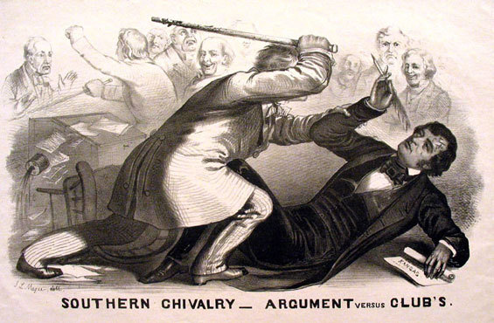

Document 28

Harper’s Weekly
“1856 Election: The Right Man for the Right Place”

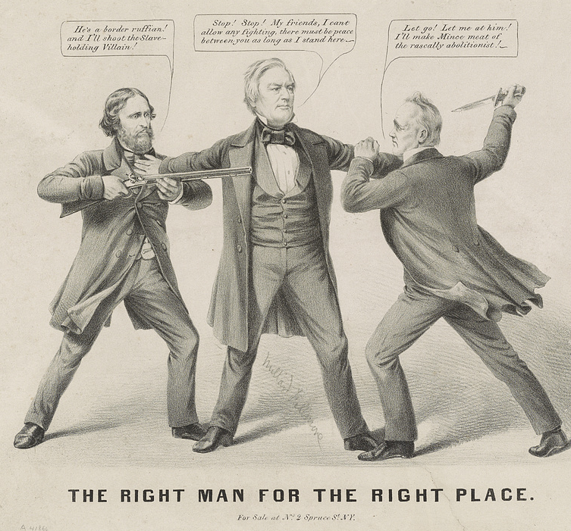
Left to right: John C. Fremont, Millard Fillmore, James Buchanan
Document 29
Portrait of William Walker, President of Nicaragua from 1856-1857
& Playbill for a theatrical presentation of William Walker’s exploits in Nicaragua, 1856
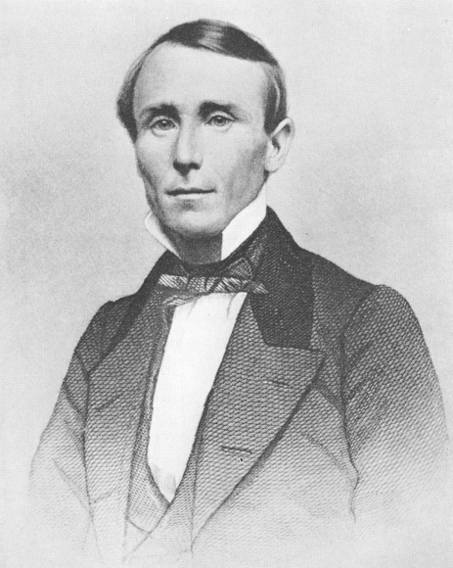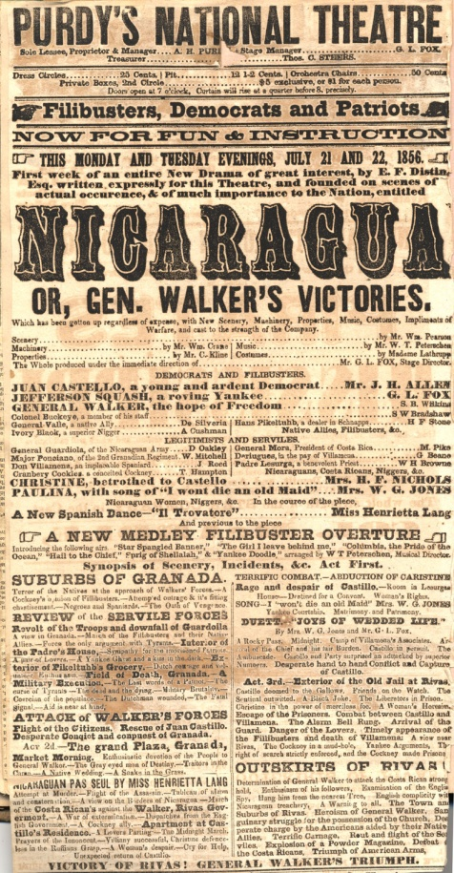
Document 30

Hinton R. Helper
The Impending Crisis of the South
1857

It is a fact well known to every intelligent Southerner that we are compelled to go to the North for almost every article of utility and adornment, from matches, shoepegs and paintings up to cotton-mills, steamships and statuary; that we have no foreign trade, no princely merchants, nor respectable artists… In [my] opinion… the causes which have impeded the progress and prosperity of the South… may all be traced to one common source, and there find solution in the most hateful and horrible word, that was ever incorporated into the vocabulary of human economy—Slavery!...

Each revolving year brings nearer the inevitable crisis. The sooner it comes the better; may heaven, through our humble efforts, hasten its advent… The first and most sacred duty of every Southerner, who has the honor and the interest of his country at heart, is to declare himself an unqualified and uncompromising abolitionist. No conditional or half-way declaration will avail; no mere threatening demonstration will succeed.

Until we examined into the matter, we thought and hoped the South was really ahead of the North in one particular, that of agriculture; but our thoughts have been changed, and our hopes frustrated, for instead of finding ourselves the possessors of a single advantage, we behold our dear native South stripped of every laurel, and sinking deeper and deeper in the depths of poverty and shame; while, at the same time, we see the North, our successful rival, extracting and absorbing the few elements of wealth yet remaining amongst us, and rising higher and higher in the scale of fame, fortune, and invulnerable power. Thus our disappointment gives way to a feeling of intense mortification, and our soul involuntarily, but justly, we believe, cries out for retribution against the treacherous, slave-driving legislators, who have so basely and unpatriotically neglected the interests of their poor white constituents and bargained away the rights of posterity. Notwithstanding the fact that the white non-slaveholders of the South, are in the majority, as five to one, they have never yet had any part or lot in framing the laws under which they live. There is no legislation except for the benefit of slavery, and slaveholders. As a general rule, poor white persons are regarded with less esteem and attention than negroes, and though the condition of the latter is wretched beyond description, vast numbers of the former are infinitely worse off. A cunningly devised mockery of freedom is guaranteed to them, and that is all. To all intents and purposes they are disfranchised, and outlawed, and the only privilege extended to them, is a shallow and circumscribed participation in the political movements that usher slaveholders into office.

The lords of the lash are not only absolute masters of the blacks, who are bought and sold, and driven about like so many cattle, but they are also the oracles and arbiters of all non-slaveholding whites, whose freedom is merely nominal, and whose unparalleled illiteracy and degradation is purposely and fiendishly perpetuated. How little the "poor white trash," the great majority of the Southern people, know of the real condition of the country is, indeed, sadly astonishing…

It is expected that the stupid and sequacious masses, the white victims of slavery, will believe, and, as a general thing, they do believe, whatever the slaveholders tell them; and thus it is that they are cajoled into the notion that they are the freest, happiest and most intelligent people in the world, and are taught to look with prejudice and disapprobation upon every new principle or progressive movement. Thus it is that the South, woefully inert and inventionless, has lagged behind the North, and is now weltering in the cesspool of ignorance and degradation.

Document 31

Stephen A. Douglas
Freeport Illinois debate with Abraham Lincoln
August 27, 1858

The next question propounded to me by Mr. Lincoln is, “Can the people of a Territory in any lawful way, against the wishes of any citizen of the United States, exclude slavery from their limits prior to the formation of a State constitution?”

I answer emphatically, as Mr. Lincoln has heard me answer a hundred times from every stump in Illinois, that in my opinion the people of a Territory can, by lawful means, exclude slavery from their limits prior to the formation of a State constitution. Mr. Lincoln knew that I had answered that question over and over again. He heard me argue the Nebraska bill on that principle all over the State in 1854, in 1855, and in 1856, and he has no excuse for pretending to be in doubt as to my position on that question.

It matters not what way the Supreme Court may hereafter decide as to the abstract question whether slavery may or may not go into a Territory under the Constitution, the people have the lawful means to introduce it or exclude it as they please, for the reason that slavery cannot exist a day or an hour anywhere, unless it is supported by local police regulations. Those police regulations can only be established by the local legislature; and if the people are opposed to slavery, they will elect representatives to that body who will by unfriendly legislation effectually prevent the introduction of it into their midst. If, on the contrary, they are for it, their legislation will favor its extension. Hence, no matter what the decision of the Supreme Court may be on that abstract question, still the right of the people to make a Slave Territory or a Free Territory is perfect and complete under the Nebraska bill. I hope Mr. Lincoln deems my answer satisfactory on that point.

Document 32

Harper’s Weekly
“A Premature Movement”
November 26, 1859

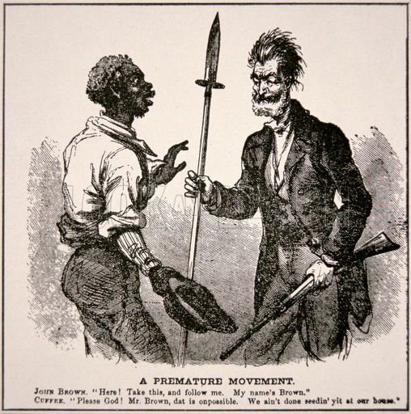

Document 33

Rickey, Mallory & Company
“The Political Quadrille: Music by Dred Scott”
1860

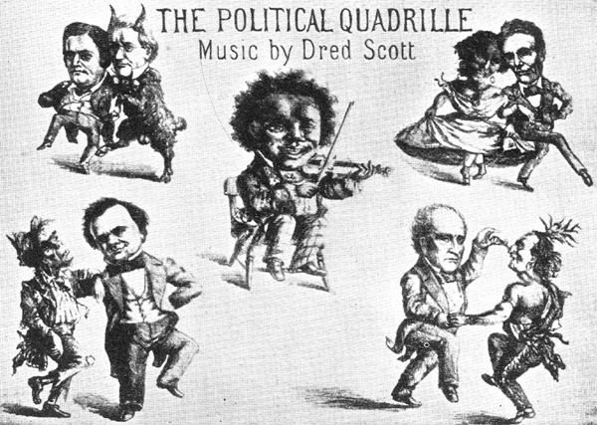
Clockwise from upper left: 1) John C. Breckenridge and James Buchanan 2) Abraham Lincoln and an African American woman 3) John Bell and a Native American man 4) Stephen A. Douglas and a ragged Irishman. At center: Dred Scott playing a fiddle.

Document 34

John J. Crittenden
“The Crittenden Compromise”
(Proposed Constitutional Amendment)
February 6, 1861

Article I
In all the territory of the United States now held, or hereafter acquired, situated north of latitude 36° 30', slavery or involuntary servitude, except as a punishment for crime, is prohibited while such territory shall remain under territorial government. In all the territory south of said line of latitude, slavery of the African race is hereby recognized as existing, and shall not be interfered with by Congress, but shall be protected as property by all the departments of the territorial government during its continuance. And when any Territory, north or south of said line, within such boundaries as Congress may prescribe, shall contain the population requisite for a member of Congress according to the then Federal ratio of representation of the people of the United States, it shall, if its form of government be republican, be admitted into the Union, on an equal footing with the original States, with or without slavery, as the constitution of such new State may provide

Article II
Congress shall have no power to abolish slavery in places under its exclusive jurisdiction, and situate within the limits of States that permit the holding of slaves.

Article III
Congress shall have no power to abolish slavery within the District of Columbia, so long as it exists in the adjoining States of Virginia and Maryland, or either, nor without the consent of the inhabitants, nor without just compensation first made to such owners of slaves as do not consent to such abolishment. Nor shall Congress at any time prohibit officers of the Federal Government, or members of Congress, whose duties require them to be in said District, from bringing with them their slaves, and holding them as such, during the time their duties may require them to remain there, and afterward taking them from the District.

Article IV
Congress shall have no power to prohibit or hinder the transportation of slaves from one State to another, or to a Territory in which slaves are by law permitted to be held, whether that transportation be by land, navigable rivers, or by the sea.

Article V
That in addition to the provisions of the third paragraph of the second section of the fourth article of the Constitution of the United States, Congress shall have power to provide by law, and it shall be its duty so to provide, that the United States shall pay to the owner who shall apply for it, the full value of his fugitive slave in all cases when the marshal or other officer whose duty it was to arrest said fugitive was prevented from so doing by violence or intimidation, or when, after arrest, said fugitive was rescued by force, the owner thereby prevented and obstructed in the pursuit of his remedy for the recovery of his fugitive slave under the said clause of the Constitution and the laws made in pursuance thereof. And in all such cases, when the United States shall pay for such fugitive, they shall have the right, in their own name, to sue the county in which said violence, intimidation, or rescue was committed, and to recover from it, with interest and damages, the amount paid by them for said fugitive slave. And the said county, after it has paid said amount to the United States may, for its indemnity, sue and recover from the wrongdoers or rescuers by whom the owner was prevented from the recovery of his fugitive slave, in like manner as the owner himself might have sued and recovered.

Article VI
No future amendment of the Constitution shall affect the five preceding articles; nor the third paragraph of the second section of the first article of the Constitution, nor the third paragraph of the second section of the fourth article of said Constitution and no amendment shall be made to the Constitution which shall authorize or give to Congress any power to abolish or interfere with slavery in any of the States by whose laws it is, or may be allowed or permitted.

Document 35

Copperhead Pamphlet
1864

