Lincoln’s First Inaugural Address

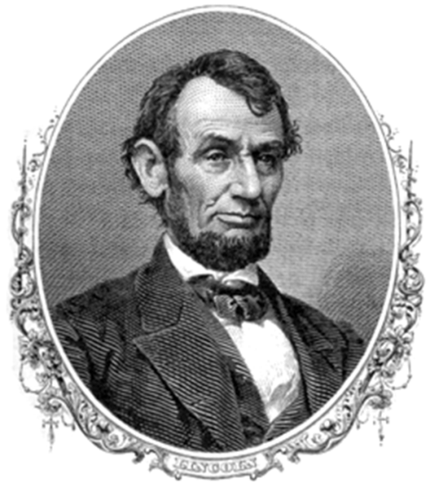

MONDAY, MARCH 4, 1861

…Apprehension seems to exist among the people of the Southern States that by the accession of a Republican Administration their property and their peace and personal security are to be endangered. There has never been any reasonable cause for such apprehension. Indeed, the most ample evidence to the contrary has all the while existed and been open to their inspection. It is found in nearly all the published speeches of him who now addresses you. I do but quote from one of those speeches when I declare that--

“I have no purpose, directly or indirectly, to interfere with the institution of slavery in the States where it exists. I believe I have no lawful right to do so, and I have no inclination to do so.”

Those who nominated and elected me did so with full knowledge that I had made this and many similar declarations and had never recanted them…

It is seventy-two years since the first inauguration of a President under our National Constitution. During that period fifteen different and greatly distinguished citizens have in succession administered the executive branch of the Government. They have conducted it through many perils, and generally with great success. Yet, with all this scope of precedent, I now enter upon the same task for the brief constitutional term of four years under great and peculiar difficulty. A disruption of the Federal Union, heretofore only menaced, is now formidably attempted.

I hold that in contemplation of universal law and of the Constitution the Union of these States is perpetual. Perpetuity is implied, if not expressed, in the fundamental law of all national governments. It is safe to assert that no government proper ever had a provision in its organic law for its own termination. Continue to execute all the express provisions of our National Constitution, and the Union will endure forever, it being impossible to destroy it except by some action not provided for in the instrument itself.

Again: If the United States be not a government proper, but an association of States in the nature of contract merely, can it, as acontract, be peaceably unmade by less than all the parties who made it? One party to a contract may violate it--break it, so to speak--but does it not require all to lawfully rescind it?

Descending from these general principles, we find the proposition that in legal contemplation the Union is perpetual confirmed by the history of the Union itself. The Union is much older than the Constitution. It was formed, in fact, by the Articles of Association in 1774. It was matured and continued by the Declaration of Independence in 1776. It was further matured, and the faith of all the then thirteen States expressly plighted and engaged that it should be perpetual, by the Articles of Confederation in 1778. And finally, in 1787, one of the declared objects for ordaining and establishing the Constitution was "to form a more perfect Union."

But if destruction of the Union by one or by a part only of the States be lawfully possible, the Union is less perfect than before the Constitution, having lost the vital element of perpetuity.

It follows from these views that no State upon its own mere motion can lawfully get out of the Union; that resolves and ordinances to that effect are legally void, and that acts of violence within any State or States against the authority of the United States are insurrectionary or revolutionary, according to circumstances.

I therefore consider that in view of the Constitution and the laws the Union is unbroken, and to the extent of my ability, I shall take care, as the Constitution itself expressly enjoins upon me, that the laws of the Union be faithfully executed in all the States…

In doing this there needs to be no bloodshed or violence, and there shall be none unless it be forced upon the national authority…

Plainly the central idea of secession is the essence of anarchy. A majority held in restraint by constitutional checks and limitations, and always changing easily with deliberate changes of popular opinions and sentiments, is the only true sovereign of a free people. Whoever rejects it does of necessity fly to anarchy or to despotism. Unanimity is impossible. The rule of a minority, as a permanent arrangement, is wholly inadmissible; so that, rejecting the majority principle, anarchy or despotism in some form is all that is left…

One section of our country believes slavery is right and ought to be extended, while the other believes it is wrong and ought not to be extended. This is the only substantial dispute. The fugitive- slave clause of the Constitution and the law for the suppression of the foreign slave trade are each as well enforced, perhaps, as any law can ever be..

Physically speaking, we can not separate. We can not remove our respective sections from each other nor build an impassable wall between them. A husband and wife may be divorced and go out of the presence and beyond the reach of each other, but the different parts of our country can not do this. They can not but remain face to face, and intercourse [trade], either amicable or hostile, must continue between them…

In your hands, my dissatisfied fellow-countrymen, and not in mine, is the momentous issue of civil war. The Government will not assail you. You can have no conflict without being yourselves the aggressors. You have no oath registered in heaven to destroy the Government, while I shall have the most solemn one to "preserve, protect, and defend it."

I am loath to close. We are not enemies, but friends. We must not be enemies. Though passion may have strained it must not break our bonds of affection. The mystic chords of memory, stretching from every battlefield and patriot grave to every living heart and hearthstone all over this broad land, will yet swell the chorus of the Union, when again touched, as surely they will be, by the better angels of our nature.

Questions:
Paragraphs 1-3: What is Lincoln’s position on abolishing slavery?

Paragraph 4: What does Lincoln mean when he refers to a “disruption the federal Union”?

Paragraphs 5-14: How does Lincoln respond to arguments in favor of secession? Do you agree with his views? Why or why not?

Paragraph 15: If war does come, who does Lincoln say will be responsible for starting it? Do you agree with his assessment?

Paragraph 16: In your own words, what is Lincoln saying to the American people in this final paragraph?

