Jacksonian Democracy

C:\Documents and Settings\jjohnson\Local Settings\Temporary Internet Files\Content.IE5\5UJ3W47H\MC900445596[1].wmf 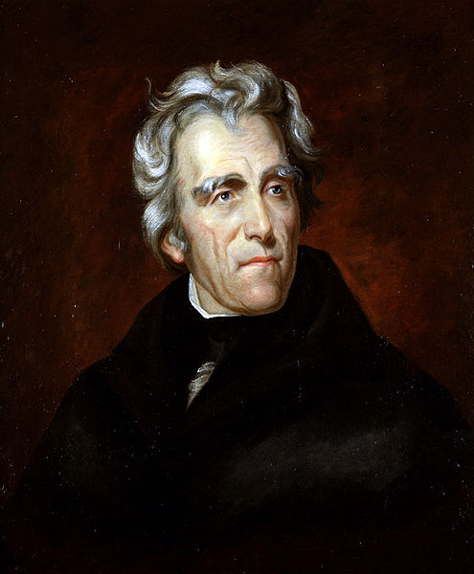 C:\Users\jjohnson\AppData\Local\Microsoft\Windows\Temporary Internet Files\Content.IE5\GYACEWNC\MC900301300[1].wmf

|  |  |
| --- | --- |
| The Marshall Court | J.Q. Adams Administration |
| Andrew Jackson | Jacksonian Democracy |
| S.C. Nullification Crisis | National Bank Crisis |
| Indian Removal | Martin Van Buren |
| Harrison & Tyler | “Did the Jacksonian Era make American government more **democratic** or more **autocratic**?” |