APUSH homework due Tuesday, August 26 –
Part 1

Student Binders
Each day, students must bring their APUSH binder with them to class. The size of the binder should be at least 1.5 inches. The contents of the binder should be the following (in order):

- A pencil pouch with the following contents:
  - Two pencils
  - Two pens
  - Two extra erasers.
  - Suggested: pencil sharpener.
- Five dividers with the following names:
  - Tools
  - Lecture Notes
  - Homework Notes
  - Writing
  - Other Assignments
- At least 100 sheets of loose leaf paper

Here are a few pictures to give you more information about what the binders should look like:

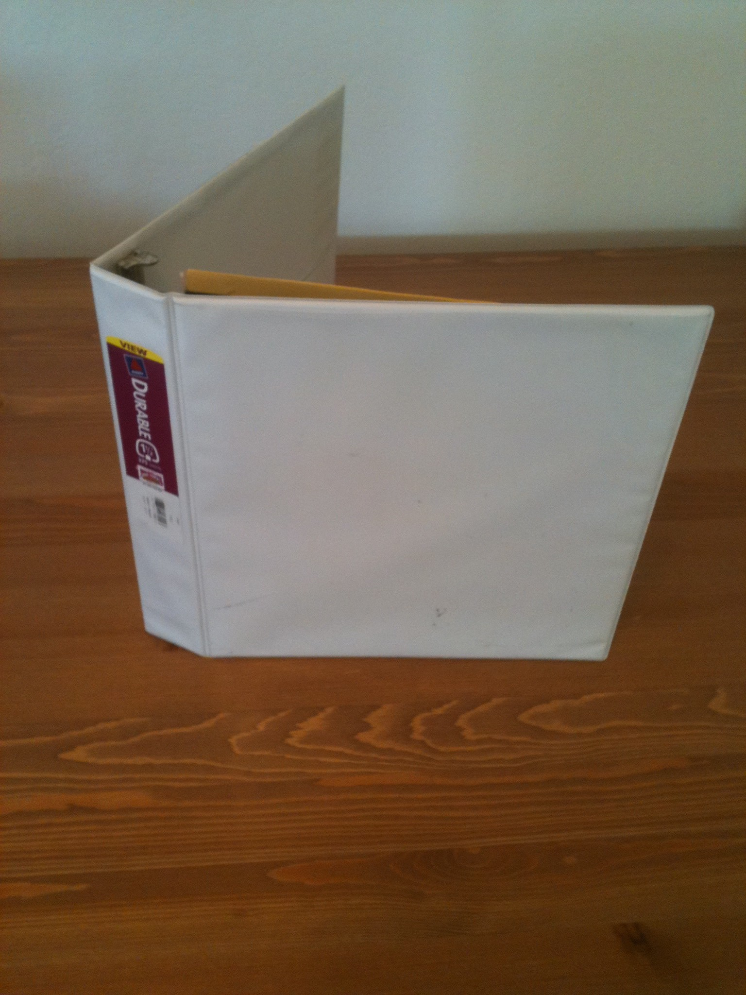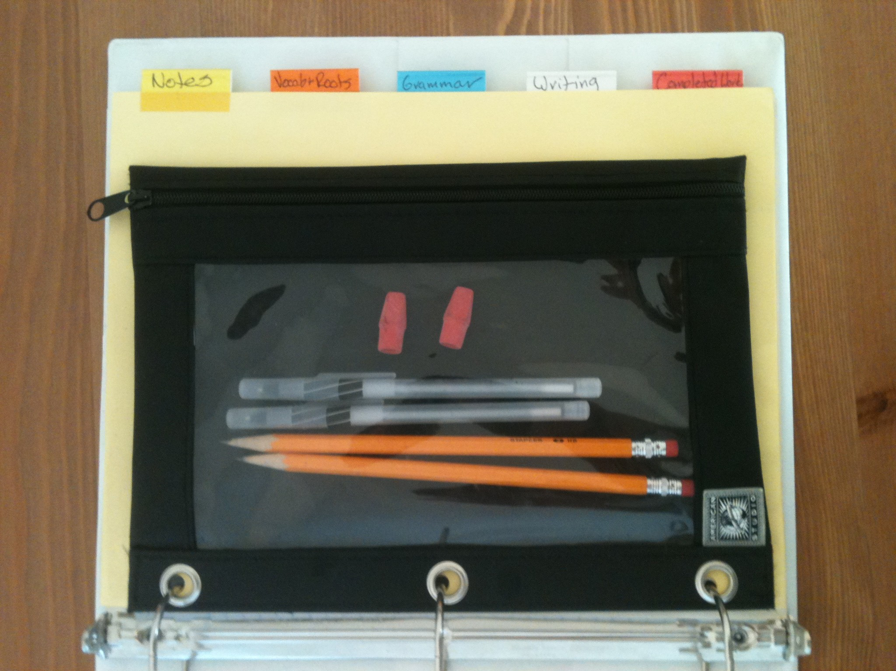

Anyone who will have difficulty buying the contents of this binder must come speak with Mrs. Ramirez by tomorrow, Friday, August 22.

You will be expected to bring your binders to class with you on Tuesday, August 26 and show them to Mrs. Ramirez at the door as you enter class.

By Wednesday, August 27 the binders must be fully set up with all of the contents that should go inside the binder.

