Hamilton’s Economic Plan
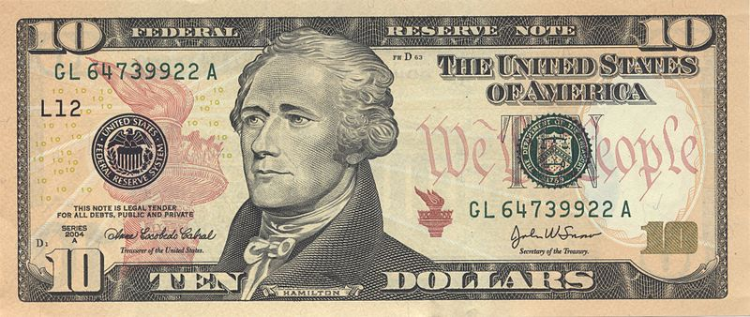
Funding the Debt at Par | Assumption of State Debts | Tariffs
Whisky Excise Tax | Sale of Government Bonds | Bank of the United States

Necessary & Proper (Elastic) Clause | Thomas Jefferson’s Response to Hamilton | Thomas Jefferson &  Albert Gallatin

