**P6 | APUSH | RAMIREZ | Gilded Age Analysis, Name:**

*The Gilded Age (1870- 1905) refers to the period in American history after the Civil War, when the most successful Americans accumulated great wealth, often at the expense of those below them on the social ladder. Mark Twain—who coined the term “Gilded Age”—liked to point out that, unlike other historical “Golden Ages,” a thin coating of gold veiled American society at the time. In his satirical work The Gilded Age: A Tale of Today (1873), he wrote about the serious problems of the era, which he believed were masked by a thin gold plating (known as a “gilding”).*

*Throughout the Gilded Age, corporations grew significantly in number, size, and influence in the United States. Use the documents below to consider the impact of big business on economics, politics, and activism. Based on the documents below, to what extent was Twain’s name for the era an appropriate one?*

**Document 1: Source: George E. McNeill, labor leader, *The Labor Movement: The Problem of Today*, 1887.**

The railroad president is a railroad king, whose whim is law. He collects tithes (taxes) by reducing wages as remorselessly as the Shah of Persia or the Sultan of Turkey, and, like them, is not amenable (cooperative, responsive) to any human power. He can discharge (banish) any employee without cause. . . . He can withhold their lawful wages. He can delay trial on a suit at law, and postpone judgment indefinitely. He can control legislative bodies, dictate legislation, subsidize the press, and corrupt the moral sense of the community. He can fix the price of freights, and thus command the food and fuel-supplies of the nation. In his right hand he holds the government; in his left hand, the people.

1. According to the author, how is the railroad president like a king, Shah, or Sultan?
2. Are these analogies reasonable?

**Document 2: Source: David A. Wells, engineer and economist, *Recent Economic Changes and Their Effect on the Production and Distribution of Wealth and the Well-Being of Society,* 1889.**

[T]he modern manufacturing system has been brought into a condition analogous to that of a military organization, in which the individual no longer works as independently as formerly, but as a private in the ranks, obeying orders, keeping step, as it were, to the tap of the drum, and having nothing to say as to the plan of his work, of its final completion, or of its ultimate use and distribution. In short, the people who work in the modern factory are, as a rule, taught to do one thing – to perform one and generally a simple operation; and when there is no more of that kind of work to do, they are in a measure helpless. The result has been that the individualism or independence of the producer in manufacturing has been in a great degree destroyed, and with it has also in a great degree been destroyed the pride which the workman formerly took in his work – that fertility of resource which formerly was a special characteristic of American workmen, and that element of skill that comes from long and varied practice and reflection and responsibility.

1. According to the author, how is the modern manufacturing system like a military organization?
2. According to the author, what had workers “lost” in this period?

**Document 3: Source: Joseph Keppler, “The Bosses of the Senate,” *Puck*, January 23, 1889.**

Sign reads, “This is a Senate of the monopolists and for the monopolists!”   
  
*The big trusts sit in the balcony while the Senate convenes…*

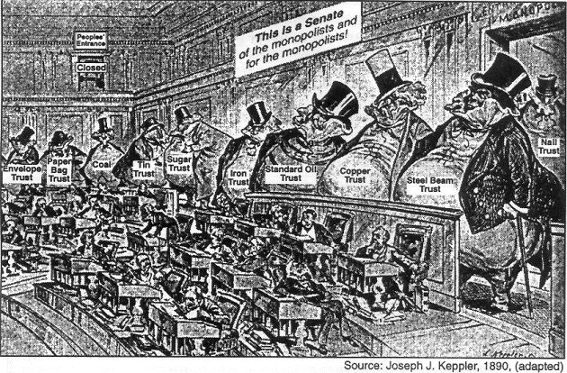

1. What is the political cartoon suggesting about the U.S. Senate?

**Document 4: Source: Selected quotes from Andrew Carnegie, circa 1890, and excerpts from his *Gospel of Wealth* (1889).**   
  
Background: *Andrew Carnegie (1835­-1919) was a massively successful business man who gave away his fortune to socially beneficial projects, most famously, the funding of libraries. In one of his most significant works, Gospel of Wealth, he explains the role of the wealthy in an unequal, democratic society. Carnegie argued that America should honor and respect the great capitalists who work for the “common good,” despite the reality that the growth of big business in his time was curbing small business opportunities, promoting the exploitation of the working people, and driving out competition.*

…No idol is more debasing than the worship of money! . . . I should be careful to choose that life which will be the most elevating in its character. To continue much longer overwhelmed by business cares and with most of my thoughts wholly upon the way to make more money in the shortest time, must degrade me beyond hope of permanent recovery. . . Man does not live by bread alone. I have known millionaires starving for lack of the nutriment which alone can sustain all that is human in man, and I know workmen, and many so-called poor men, who revel in luxuries beyond the power of those millionaires to reach. It is the mind that makes the body rich. There is no class so pitiably wretched as that which possesses money and nothing else. Money can only be . . . useful drudge. My aspirations take a higher flight. Mine be it to have contributed to the enlightenment and the joys of the mind, to the things of the spirit, to all that tends to bring into the lives of the toilers . . . sweetness and light. I hold this the noblest possible use of wealth.

*Gospel of Wealth—*The problem of our age is the administration of wealth, so that the ties of brotherhood may still bind together the rich and poor in harmonious relationship. The conditions of human life have not only been changed, but revolutionized, within the past few hundred years. In former days there was little difference between the dwelling, dress, food, and environment of the chief and those of his retainers. . . . The contrast between the palace of the millionaire and the cottage of the laborer with us to­day measures the change which has come with civilization.

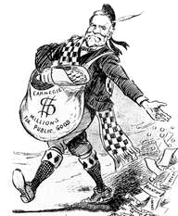This change, however, is not to be deplored, but welcomed as highly beneficial. It is well, nay, essential for the progress of the race, that the houses of some should be homes for all that is highest and best in literature and the arts, and for all the refinements of civilization, rather than that none should be so. Much better this great irregularity than universal squalor. Without wealth there can be no Maecenas [*a rich Roman patron of the arts*]. The "good old times" were not good old times. Neither master nor servant was as well situated then as to day. A relapse to old conditions would be disastrous to both-not the least so to him who serves-and would sweep away civilization with it. . . .

We start, then, with a condition of affairs under which the best interests of the race are promoted, but which inevitably gives wealth to the few. Thus far, accepting conditions as they exist, the situation can be surveyed and pronounced good. The question then arises-and, if the foregoing be correct, it is the only question with which we have to deal-What is the proper mode of administering wealth after the laws upon which civilization is founded have thrown it into the hands of the few? And it is of this great question that I believe I offer the true solution. It will be understood that fortunes are here spoken of, not moderate sums saved by many years of effort, the returns from which are required for the comfortable maintenance and education of families. This is not wealth, but only competence, which it should be the aim of all to acquire.

Andrew Carnegie, distributing "millions for public good," as part of his Gospel of Wealth, 1901

There are but three modes in which surplus wealth can be disposed of. It can be left to the families of the decedents; or it can be bequeathed for public purposes; or, finally, it can be administered during their lives by its possessors. Under the first and second modes most of the wealth of the world that has reached the few has hitherto been applied. Let us in turn consider each of these modes. The first is the most injudicious. In monarchial countries, the estates and the greatest portion of the wealth are left to the first son, that the vanity of the parent may be gratified by the thought that his name and title are to descend to succeeding generations unimpaired. The condition of this class in Europe to­day teaches the futility of such hopes or ambitions. The successors have become impoverished through their follies or from the fall in the value of land. . . . Why should men leave great fortunes to their children? If this is done from affection, is it not misguided affection? Observation teaches that, generally speaking, it is not well for the children that they should be so burdened. Neither is it well for the state. Beyond providing for the wife and daughters moderate sources of income, and very moderate allowances indeed, if any, for the sons, men may well hesitate, for it is no longer questionable that great sums bequeathed oftener work more for the injury than for the good of the recipients. Wise men will soon conclude that, for the best interests of the members of their families and of the state, such bequests are an improper use of their means.

As to the second mode, that of leaving wealth at death for public uses, it may be said that this is only a means for the disposal of wealth, provided a man is content to wait until he is dead before it becomes of much good in the world. . . . The cases are not few in which the real object sought by the testator is not attained, nor are they few in which his real wishes are thwarted. . . .

The growing disposition to tax more and more heavily large estates left at death is a cheering indication of the growth of a salutary change in public opinion. . . . Of all forms of taxation, this seems the wisest. Men who continue hoarding great sums all their lives, the proper use of which for public ends would work good to the community, should be made to feel that the community, in the form of the state, cannot thus be deprived of its proper share. By taxing estates heavily at death, the state marks its condemnation of the selfish millionaire's unworthy life.

. . . This policy would work powerfully to induce the rich man to attend to the administration of wealth during his life, which is the end that society should always have in view, as being that by far most fruitful for the people. . . .

There remains, then, only one mode of using great fortunes: but in this way we have the true antidote for the temporary unequal distribution of wealth, the reconciliation of the rich and the poor-a reign of harmony-another ideal, differing, indeed from that of the Communist in requiring only the further evolution of existing conditions, not the total overthrow of our civilization. It is founded upon the present most intense individualism, and the race is prepared to put it in practice by degrees whenever it pleases. Under its sway we shall have an ideal state, in which the surplus wealth of the few will become, in the best sense, the property of the many, because administered for the common good, and this wealth, passing through the hands of the few, can be made a much more potent force for the elevation of our race than if it had been distributed in small sums to the people themselves. Even the poorest can be made to see this, and to agree that great sums gathered by some of their fellow­ citizens and spent for public purposes, from which the masses reap the principal benefit, are more valuable to them than if scattered among them through the course of many years in trifling amounts.

This, then, is held to be the duty of the man of Wealth: First, to set an example of modest, unostentatious living, shunning display or extravagance; to provide moderately for the legitimate wants of those dependent upon him; and after doing so to consider all surplus revenues which come to him simply as trust funds, which he is called upon to administer, and strictly bound as a matter of duty to administer in the manner which, in his judgment, is best calculated to produce the most beneficial result for the community-the man of wealth thus becoming the sole agent and trustee for his poorer brethren, bringing to their service his superior wisdom, experience, and ability to administer-doing for them better than they would or could do for themselves.

Note: Like many of his peers in business, Carnegie ruthlessly slashed wages to further increase profit, leading to a personal fortune the nation had never witnessed. In later years he gave 90% of his wealth away to various philanthropic causes which supported education, medical research, libraries, war prevention research, and the funding of universities and academies.

1. What do you think Carnegie meant by his title, the “Gospel of Wealth”? Do you agree with Carnegie’s “Gospel of Wealth”?
2. How does Carnegie view inequality? Why does he argue that the “temporary unequal distribution of wealth” is beneficial?
3. Why does Carnegie oppose leaving surplus wealth to families? How would you have felt about this as Carnegie’s son/daughter?

1. To what extent is social Darwinism evident in Carnegie’s writing? Where can you find it?

1. Taken the document as a whole, how do you think Carnegie feels about communism (in theory) and socialism? Revisit *Intro to Politics* document if necessary.

**Document 5: Source: “People’s Party Platform,” *Omaha Morning World-Herald*, July 5, 1892.**

*The People's party, more commonly known as the Populist party, was a short-lived political party organized in St. Louis in 1892 to represent the common folk—especially farmers—against the entrenched interests of railroads, bankers, processers, corporations, and the politicians in league with such interests. At its first national convention in Omaha in July 1892, the party ratified the so-called Omaha Platform. The party was somewhat influential from 1892-1896 but faded away rapidly after the election of ’96, when the Populists decided to endorse the Democratic presidential nominee, William Jennings Bryan. It garnered most support among common cotton farmers in the South and wheat farmers in the plains states.*

The conditions which surround us best justify our cooperation; we meet in the midst of a nation brought to the verge of moral, political, and material ruin. Corruption dominates the ballot-box, the Legislatures, the Congress, and touches even . . . the bench. The people are demoralized; most of the States have been compelled to isolate the voters at the polling places to prevent universal intimidation and bribery . . . business [is] prostrated, homes covered with mortgages, labor impoverished, and the land concentrating in the hands of capitalists. The urban workmen are denied the right to organize for self-protection, imported pauperized labor beats down their wages, a hireling standing army, unrecognized by our laws, is established to shoot them down, and they are rapidly degenerating into European conditions. The fruits of the toil of millions are badly stolen to build up colossal fortunes for a few, unprecedented in the history of mankind; and the possessors of these, in turn, despise the Republic and endanger liberty.

We have witnessed for more than a quarter of a century the struggles of the two great political parties for power and plunder, while grievous wrongs have been inflicted upon the suffering people. We charge that the controlling influences dominating both these parties have permitted the existing dreadful conditions to develop without serious effort to prevent or restrain them. Neither do they now promise us any substantial reform. They have agreed together to ignore, in the coming campaign, ever issue but one. They propose to drown the outcries of a plundered people with the uproar of a sham battle over the tariff…

Assembled on the anniversary of the birthday of the nation, and filled with the spirit of the grand general and chief who established our independence, we seek to restore the government of the Republic to the hands of the ''plain people,'' with which class it originated. We assert our purposes to be identical with the purposes of the National Constitution; to form a more perfect union and establish justice, insure domestic tranquility, provide for the common defense, promote the general welfare, and secure the blessings of liberty for ourselves and our posterity. . . . We pledge ourselves that if given power we will labor to correct these evils by wise and reasonable legislation, in accordance with the terms of our platform. We believe that the power of government—in other words, of the people—should be expanded as rapidly and as far as the good sense of an intelligent people and the teaching of experience shall justify, to the end that oppression, injustice, and poverty shall eventually cease in the land.

We declare, therefore—

* RESOLVED, We believe that the money of the country should be kept as much as possible in the hands of the people, and hence we demand that all State and national revenues shall be limited to the necessary expenses of the government, economically and honestly administered.
* RESOLVED, Transportation being a means of exchange and a public necessity, the government should own and operate the railroads in the interest of the people. The telegraph and telephone, like the post-office system, being a necessity for the transmission of news, should be owned and operated by the government in the interest of the people.
* RESOLVED, That we condemn the fallacy of protecting American labor under the present system, which opens our ports to the pauper and criminal classes of the world and crowds out our wage-earners; and we denounce the present ineffective laws against contract labor, and demand the further restriction of undesirable emigration.
* RESOLVED, That we cordially sympathize with the efforts of organized workingmen to shorten the hours of labor, and demand a rigid enforcement of the existing eight-hour law on Government work, and ask that a penalty clause be added to the said law.
* RESOLVED, That we oppose any subsidy or national aid to any private corporation for any purpose.
* RESOLVED, That this convention sympathizes with the Knights of Labor…

1. What events/issues prompted the formation of the People’s (Populist) Party? What were their goals?
2. Why do you suspect this short-lived party is significant in American history?

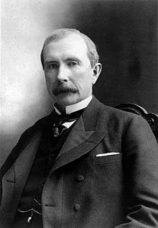**Document 6: Source: George Rice, “How I Was Ruined by Rockefeller,” *New York World*, October 16, 1898.**I am but one of many victims of Rockefeller’s colossal combination, and my story is not essentially different from the rest…I established what was known as the Ohio Oil Works…I found to my surprise at first, though I afterward understood it perfectly, that the Standard Oil Company was offering the same quality of oil at much lower prices than I could do – from one to three cents a gallon less than I could possibly sell it for. I sought for the reason and found that the railroads were in league with the Standard Oil concern at every point, giving it discriminating rates and privileges of all kinds as against myself and all outside competitors.

1. How did Standard Oil eliminate its competition?
2. How might Rockefeller defend himself to Mr. Rice?

**Document 7: Source: PBS, American Experience—The Gilded Age, 2009.**

"What is the chief end of man?--to get rich. In what way?--dishonestly if we can; honestly if we must" (Mark Twain, 1871). During the "Gilded Age," every man was a potential Andrew Carnegie, and Americans who achieved wealth celebrated it as never before. In New York, the opera, the theatre, and lavish parties consumed the ruling class' leisure hours. Sherry's Restaurant hosted formal horseback dinners for the New York Riding Club. Mrs. Stuyvesant Fish once threw a dinner party to honor her dog who arrived sporting a $15,000 diamond collar.

While the rich wore diamonds, many wore rags. In 1890, 11 million of the nation's 12 million families earned less than $1200 per year; of this group, the average annual income was $380, well below the poverty line. Rural Americans and new immigrants crowded into urban areas. Tenements spread across city landscapes, teeming with crime and filth. Americans had sewing machines, phonographs, skyscrapers, and even electric lights, yet most people labored in the shadow of poverty. To those who worked in Carnegie's mills and in the nation's factories and sweatshops, the lives of the millionaires seemed immodest indeed. An economist in 1879 noted "a widespread feeling of unrest and brooding revolution." Violent strikes and riots wracked the nation through the turn of the century. The middle class whispered fearfully of "carnivals of revenge."

For immediate relief, the urban poor often turned to political machines. During the first years of the Gilded Age, Boss Tweed's Tammany Hall provided more services to the poor than any city government before it, although far more money went into Tweed's own pocket. Corruption extended to the highest levels of government, particularly during Ulysses S. Grant's presidency, which cost Republicans key support.

Europeans were aghast. America may have had money and factories, they felt, but it lacked sophistication. When French Prime Minister Georges Clemenceau visited, he said the nation had gone from a stage of barbarism to one of decadence—without achieving any civilization between the two.

1. What is meant by the “Gilded Age”? What characteristics are associated with it?

**Document 8: Source: Horace Taylor, 1900.**

1. What is the perspective of the cartoonist? What point are they trying to make?

1. How true do you suspect this message is today?

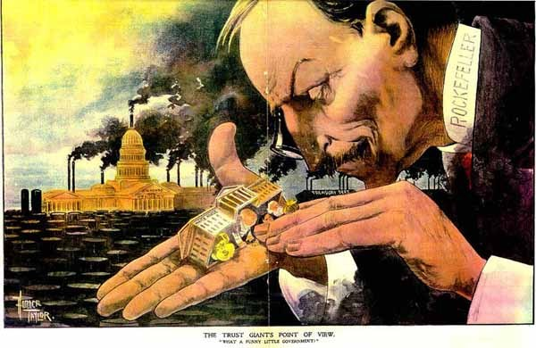

Text at bottom reads, “The Trust Giant’s Point of View:

What a funny little government.”