If the Federalists and Anti-Federalists (Democratic-Republicans) were alive today……
Due Monday, October 20. 50 PTS
**This is a partner assignment…
QUESTION: IF THE FEDERALISTS AND ANTI-FEDERALISTS WERE ALIVE TODAY, HOW WOULD YOU LEARN ABOUT THEIR DIFFERENCES??
Twitter!
FACEBOOK!
INSTAGRAM!

FOR FACEBOOK:
You are charged with the task of making a facebook page for that shows the differences between Federalist and Anti-Federalist. You must create a facebook profile, complete with a wall, friends and groups for your assigned side. Mrs. Ramirez has a template that you should follow.

FOR INSTAGRAM:
You are charge with making an instagram that show the differences between the federalist and anti-federalist. You will need to create a series 5 – 8 of instagram posts, complete with comments, to show your side of the debate. You can hand draw pictures or bring in pictures printed from the internet. Make at least one of your posts a meme. Pick an issue or idea of the federalists or anti-federalists, think of a symbol to show that idea, and make an instagram post out of it.

FOR TWITTER:
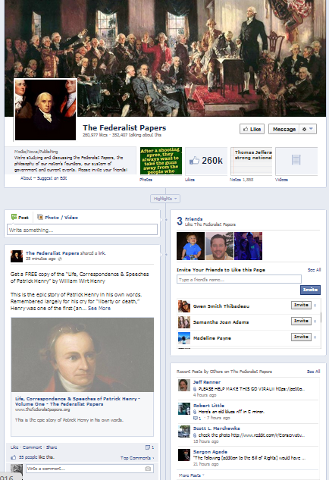
You are charged with making a twitter that demonstrates the differences between the federalist and anti-federalist.
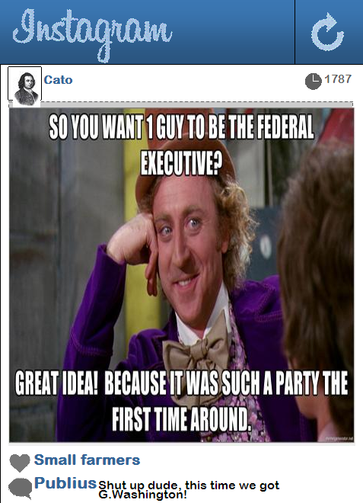

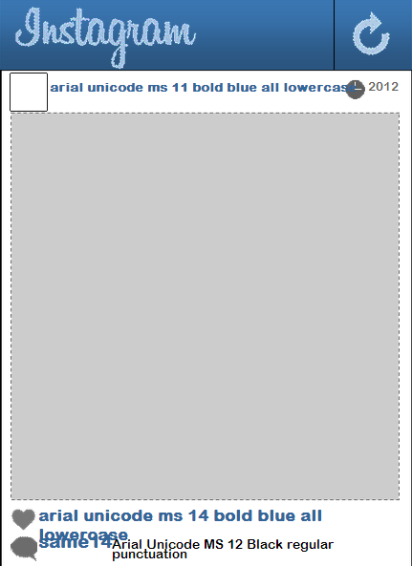

If the Federalists and Anti-Federa

