P8 | APUSH | | Domestic Politics, Culture, and Protest: ‘50s-‘70s, D___
Name:
This document will look at the ways in which domestic policies and social realities of the 1950s-‘70s initiated discontent and protest amongst a wide array of groups—liberals, conservatives, blacks, whites, homosexuals, etc. Foreign policies that initiated discontent and protest (such as the anti-war protests of the Vietnam era) will be covered in our Cold War packet.
1950s-early ‘60s: Culture + Discontent
1950s—Subsidizing Prosperity and Progress:
Though Eisenhower was eventually persuaded to run as a Republican in the 1952 election, his years as president showcased his often nonpartisan nature. In many ways he accepted the New Deal legacy of Democrat FDR, and continued efforts to improve the quality of life for all Americans.
During the Eisenhower years, the federal government played a crucial role in subsidizing programs that helped millions of Americans achieve middle-class status. Federal aid helped: 1) people buy homes and attend college and technical schools, 2) small businesses, who were given business loans, and 3) construction businesses, so as to build residential neighborhoods in new suburbs (it should be noted that this was done in a discriminatory fashion, with aid being parceled out to white communities and for white neighborhood construction). Also under Eisenhower was the Federal Highway Act of 1956, which was another key boost to postwar growth in America. It authorized billions of dollars of construction for a national interstate highway system. The financing came from new taxes on gasoline, oil, tires, buses, and trucks. It quickly became the nation’s largest public works program. The decision to investment paid off: subsidizing the highway system stimulated both the automobile industry and suburb building. However, it also accelerated the decline of American mass transit; by 1970, the nation possessed the world’s best roads and one of the worst public transportation systems.
1950s houses in the suburban development of Levittown, New York, one of the first suburbs built as planned [white] communities. Developer William Levitt was the first entrepreneur to bring mass-production techniques to home building.

In 1958, the National Defense Education Act was passed, which allocated millions of dollars in grants for state universities to upgrade their science, mathematics, and technology facilities. It also created millions of low-interest loans for college students. Again, the investment paid off, as evidenced by economic growth.
- Would FDR approve of the legislation signed by President Eisenhower discussed above? Why or why not?
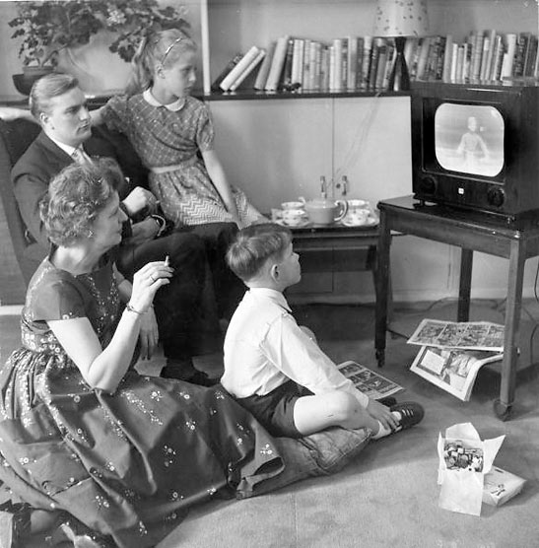
Mass culture and its discontents—1950s:
No mass medium has ever achieved such power and popularity as rapidly as television. The basic technology for broadcasting visual images with sound had been developed by the late ‘30s, but WWII had postponed its introduction to the public until ‘46. By 1960, nearly nine in 10 American families owned at least one set, which was turned on an average of five hours a day. TV reshaped leisure time and political life, and helped create a new kind of national community defined by the buying and selling of consumer goods.
Popular shows, like Leave It to Beaver, epitomized the ideal suburban American family—in image that was seen as so important as the face of capitalism during the Cold War. Their plots focused on genial crises, usually brought on by a child’s mischief, which was then resolved by kindly fathers. What is most striking about these shows is what is absent—politics, social issues, cities, and most ethnic and racial groups. Prime-time entertainment shows carefully avoided any references to the political issues of the day. Network executives bowed to the conformist climate created by the Cold War; any hint of political controversy could scare of sponsors.
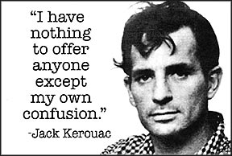
Important voices challenged the economic trends and cultural conformity of the prewar years. Academics, journalists, novelists, and poets offered a variety of works criticizing the overall direction of American life, with its emphasis on conformity, status, and material consumption. The “Beat” literary movement formed in the ‘50s; followers of this movement, called beats or beatniks, lived nonconformist lives and cared little for material goods, expressing their alienation from conventional, or “square,” society. They tended to shun regular work, focusing instead on “working” to achieve a higher spiritual consciousness through the heightened sensory awareness that might be induced by drugs, jazz, or Buddhism.
Many beat poets and writers believed in imposing as little structure as possible on their artistic works, which often had a free, open form. Beat writers sought to liberate poetry from academic overrefinement and bring it “back to the streets.” They often read their works to the accompaniment of progressive jazz and verse was often chaotic and liberally sprinkled with obscenities. The goal was to create unstructured composition free of plan or revision, to convey the immediacy of experience.
Jack Kerouac’s novel of the movement, On the Road, published in 1957, describes a nomadic search across America for authentic experiences, people, and values. A rapid typist, Kerouac hit on the idea of typing nonstop to get the “kickwriting” momentum he wanted. He was convinced that his verbal flow was hampered when he had to change paper at the end of a page. As such, Kerouac taped together twelve-foot-long sheets of tracing paper, trimmed at the left margin so as to fit into his typewriter, and fed them into his machine as a continuous roll. He took Benzedrine to stay awake, finishing the novel (at approximately 305 pages) in a record three weeks. When Kerouac finished the book it was a roll of paper typed as a single-spaced paragraph 120 feet long. Kerouac would later state, “I have an irrational lust to set down everything I know.” His style of writing would later be called “spontaneous prose” or “wild form prose,” which was quickly mimicked by many contemporaries.
Though not exceedingly popular in the ‘50s, beatniks and other social critics of the time foreshadowed the mass youth rebellion and counterculture to come in the ‘60s. Many of their ideas would reverberate through the political and cultural upheavals of the ‘60s and ‘70s.
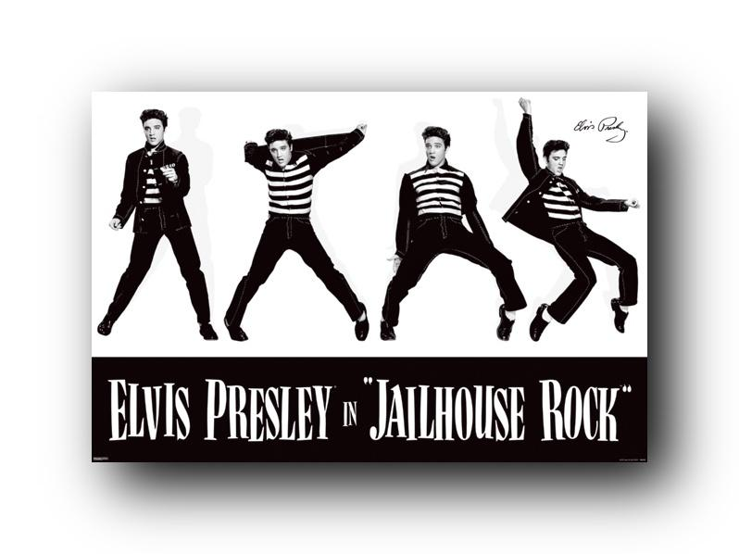
Television—along with radio—also catapulted Rock ‘n’ Roll onto the scene. [That term was popularized by a white DJ to describe the black rhythm and blues he played on the air and promoted in live concerts.] African Americans were the first pioneers of what we call Rock ‘n’ Roll today and gained millions of white fans. Yet established record companies, which ignored black music, offered toned-down “cover” versions by white pop singers of rhythm and blues originals. By the late ‘50s, Elvis Presley’s Rock ‘n’ Roll “reinvented” American pop music and became a symbol of rebellious youth and an embodiment of youthful sexuality. As such, it faced mounting opposition, particularly in the South, where long-standing racism led to fears that white females might be attracted to black music and black performers; the undercurrent beneath this opposition was a deep anxiety over the more open expression of sexual feelings by both performers and audiences. Opponents of Rock ‘n’ Roll also held the new genre as responsible for the apparent decline in parental control over their kids, and the potentially related problem of juvenile delinquency, which increased during this time.
The 1950s also marked a turning point in women’s history, with female writers and activists challenging the notion of the “beautiful ideal,” which had existed in the U.S. since the country’s inception. The “beautiful ideal” has been understood to mean that physical attractiveness and vulnerability are women’s most important assets and that women should strive to achieve their physical and emotional “beautiful ideal.” Such female activism would coalesce in the Women’s Liberation Movement of the ‘60s.
- How was U.S. culture and society changing in the 1950s? Which discontented group of those discussed here (Beatniks, anti-Rock ‘n’ Rollers, female activists) do you most sympathize with?

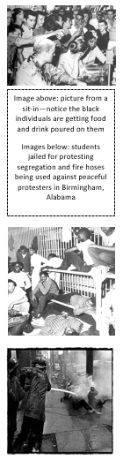
Birth of the Civil Rights Movement:
The experiences of African Americans during WWII and immediately after laid the foundation for the Civil Rights struggle of the 1950s and ‘60s. Nearly 1 million black men and women had served in the armed forces. This discrepancy between fighting totalitarianism abroad while enduring segregation and other racist practices in the military embittered many combat veterans and their families (enter Double V Campaign—see World War II Note Guide). After the war, civil rights became center stage for the first time since Reconstruction. Black voters had already begun switching their allegiance to the Democratic Party during the New Deal. A series of symbolic and substantial acts by the Truman administration solidified that shift. In 1946, Truman created a President’s Committee on Civil Rights. And in 1948, Truman issued an executive order barring segregation in the armed forces.
Image above: picture from a sit-in—notice the black individuals are getting food and drink poured on them
Images below: students jailed for protesting segregation and fire hoses being used against peaceful protesters in Birmingham, Alabama
During the ‘50s, membership in the NAACP skyrocketed, with many whites now joining the group. The NAACP initiated voter registration drives, organized protests, presented defense attorneys for cases like Brown v. Board (1954), and lobbied government at all levels against discrimination, such as that in housing and employment, which ran rampant throughout much of the country.
The legal breakthrough represented in Brown heartened opponents of segregation everywhere and demonstrated the potential for using the federal court system as a weapon against discrimination and as a means of protecting the full rights of citizenship. Yet the widespread opposition to Brown and its implications showed the limits of a strictly legal strategy. In Little Rock, for example, the ugly face of racism received wide coverage in the mass media and quickly sobered the more optimistic champions of integration. However welcome Eisenhower’s intervention, his reluctance to endorse desegregation suggested that civil rights activists could still not rely on federal help.
It was in this context that the famous Montgomery Bus Boycott took place (1955). The event stemmed from Rosa Parks’ arrest for refusing to give up her seat to a white passenger in accordance with Jim Crow laws. Parks was a leader of a local NAACP chapter and worked with others to organize a protest of her arrest. 30,000 African Americans took up the NAACP’s call to boycott the city busses for several days. Many poured into the city for speeches and prayers—led by the young Rev. MLK, Jr. In opening he said, “We are here . . . because first and foremost we are American citizens, and we are determined to apply our citizenship to the fullness of its means. . . [T]here comes a time . . . when people get tired of being flung across the abyss of humiliation, when they experience the bleakness of nagging despair. . . If we are wrong, justice is a lie. . . [W]e are determined here in Montgomery to work and fight until justice runs down like water and righteousness like a mighty stream.” Ultimately, the boycott would severely undermine the revenues of bus companies and lead to the arrest of many leaders of the boycott, including MLK, Jr. Reporters and TV crews covered the trials, which found King and others guilty. But an appeal to federal courts ended in the repeal of Montgomery’s bus segregation ordinances; after almost a year, the boycotters had won.
Their victory would inspire a new mass movement to ensure civil rights for African Americans. The struggle to end legal segregation took root in scores of towns and cities across the nation. African Americans led the fights, but had many white allies. Together, they engaged in boycotts, sit-ins, mass civil disobedience, and legal battles in state and federal courts. By 1963, the massive March on Washington would win the endorsement of President John F. Kennedy, and his successor, Lyndon B. Johnson, would push through the landmark Civil Rights Act and Voting Rights Act (see 1960s section).
- Were the strategies employed by the civil rights activists in the ‘50s warranted given the circumstances? Why or why not?
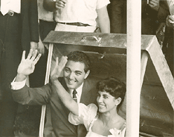
Source 1: “Cold War, Warm Hearth” excerpt, by Elaine Tyler May, Ph.D University of Minnesota, History Dept.
In the summer of 1959, a young couple married and spent their honeymoon in a fallout shelter. Life magazine featured the “sheltered honeymoon” with a photograph of the duo smiling on their lawn, surrounded by dozens of canned goods and supplies. Another photograph showed them kissing as they descended twelve feet underground into the 22-ton, steel and concrete, 8-by-11-foot shelter where they would spend the next two weeks. The article quipped that “fallout can be fun” and described the newlyweds’ adventure as fourteen days of “unbroken togetherness.” As the couple embarked on married life, all they had to enhance their honeymoon were some consumer goods and their privacy. This is a powerful image of the nuclear family in the nuclear age: isolated, sexually charged, cushioned by abundance, and protected against impending doom by the wonders of modern technology.
The stunt was little more than a publicity device; yet, in retrospect it takes on symbolic significance. For in the early years of the Cold War, amid the uncertainties brought about by World War II and its aftermath, the home seemed to offer a secure private nest removed from the dangers of the outside world. The message was ambivalent, however, for the family also seemed particularly vulnerable. It needed heavy protection against the intrusions of forces outside itself. The self-contained home held out the promise of security in an insecure world. It also offered a vision of abundance and fulfillment. As the Cold War began, young postwar Americans were rushing into this vision of marriage and family life.
Demographic indicators show that in the period immediately following World War II, Americans were more eager than ever to establish families. The bomb-shelter honeymooners were part of a cohort of Americans of all racial, ethnic, and religious groups, of all socio-economic classes and education levels, who lowered the age at marriage for both men and women, and quickly brought the birthrate to a twentieth-century high after more than a hundred years of steady decline, producing the “baby boom.” Although the nation remained divided along lines of race and class, family fever swept the nation and affected all Americans. The trend of early marriage and relatively large families these young adults established lasted for more than two decades. From the 1940s through the early 1960s, Americans married at a higher rate and at a younger age than did their European counterparts.
Why did postwar Americans turn to marriage and parenthood with such enthusiasm and commitment? Scholars frequently point to the family boom as the inevitable result of a return to peace and prosperity. They argue that postwar Americans were eager to put the disruptions and hardships of economic depression and war behind them and enjoy the abundance at home. There is, of course, some truth in this claim, but prosperity followed other wars in our history, notably World War I, with no similar increase in marriage and childbearing. Peace and affluence alone are inadequate to explain the many complexities of the postwar domestic explosion. The demographic trends went far beyond what was expected from a return to peace. Indeed, nothing on the surface of postwar America explains the rush of young Americans into marriage, parenthood, and traditional gender roles.
It might have been otherwise. The Great Depression of the 1930s brought about widespread challenges to traditional gender roles that could have led to a restructured home. The war intensified these challenges and pointed the way toward radical alterations in the institutions of work and family life. Wartime brought thousands of women into the paid labor force when men left to enter the Armed Forces. After the war, expanding job and educational opportunities, as well as the increasing availability of birth-control devices, might well have led young people to delay marriage or not marry at all, and to have fewer children if they did marry. Indeed, many observers at the time feared that these changes seriously threatened the stability of the American family. Yet, the evidence overwhelmingly indicates that postwar American society experienced a surge in family life and a reaffirmation of domesticity that rested on distinct roles for women and men.
What makes the postwar demographic explosion even more curious and remarkable is its pervasiveness across all groups in the society. Americans of all backgrounds rushed into marriage and childbearing, even though many of these newly formed families—most notably large numbers of Americans of color—were excluded from suburbia, the site of the “American way of life.” Racial and class divisions were concealed beneath an aura of unity in the aftermath of the war. Post–World War II America presented itself as a unified nation, politically harmonious and blessed with widespread affluence. Emerging triumphant from a war fought against racist and fascist regimes, spared the ravages of war-torn Europe and Asia, and prosperous from the booming wartime economy, the United States embraced its position as the “leader of the free world.”
But major challenges lay ahead if the nation was to maintain its leadership in the world. The atomic blasts that devastated Hiroshima and Nagasaki marked both the end of the Second World War and the beginning of the Cold War. The United States now faced its former ally, the Soviet Union, as its major foe. The Cold War was largely an ideological struggle between the two superpowers, both hoping to increase their power and influence across the globe. The divisions in American society along racial, class, and gender lines threatened to weaken the society at home and damage its prestige in the world. In the propaganda battles that permeated the era, American leaders promoted the American way of life as the triumph of capitalism, allegedly available to all who believed in its values. This way of life was characterized by affluence, located in suburbia, and epitomized by white middle-class nuclear families. Increasing numbers of Americans gained access to this domestic ideal—but not everyone who aspired to it could achieve it.
Poverty excluded many from suburban affluence; racism excluded others. Nevertheless, experts and officials insisted that the combined forces of democracy and prosperity would bring the fruits of the “good life” to all. Racial strife, they asserted, was diminishing. Workers, they argued, were prosperous. But anxieties surrounding these issues did not disappear. Policymakers perceived racial and class divisions as particularly dangerous, because dissatisfied workers and racial minorities might be drawn to left-wing political agitation, leading to socialism or even communism. According to the Cold War ethos of the time, conflict within the United States would harm our image abroad, strengthen the Soviet Union, and weaken the nation, making it vulnerable to communism. The worst-case scenario was Communist takeover and the defeat of the United States in the Cold War. Although strategists and foreign policy experts feared that the Soviet Union might gain the military strength and territorial expansion to achieve world domination, many leaders, pundits, and other observers worried that the real dangers to America were internal ones: racial strife, emancipated women, class conflict, and familial disruption.
To alleviate these fears, Americans turned to the family as a bastion of safety in an insecure world, while experts, leaders, and politicians promoted codes of conduct and enacted public policies that would bolster the American home. Like their leaders, most Americans agreed that family stability appeared to be the best bulwark against the dangers of the Cold War era. Because of the political, ideological, and institutional developments that converged at the time, young adults were especially eager for the comforts and security that the nuclear family promised. Like the young couple who honeymooned in the fallout shelter, postwar Americans set their sights on the affluent and protected home as the location of their own personal pursuit of happiness.
- For what reasons do you suspect the “sheltered honeymoon” was featured in Life magazine in the late 50s?
Source 2: “The Feminine Mystique,” published in 1963 by Betty Friedan (writer, activist, and feminist) describes the widespread unhappiness of women in the 1950s and early 1960s, despite their apparent material comfort and familial stability. Throughout the book, Friedan discusses a crisis in female identity and her hopes for female self-actualization. The book is regarded as one of the most influential nonfiction books of the 20th century and is widely credited with sparking a new wave of feminism in America. See excerpt below:
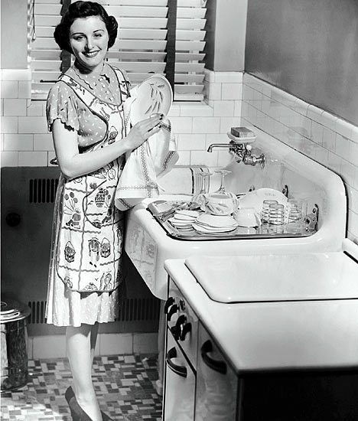
The problem lay buried, unspoken, for many years in the minds of American women. It was a strange stirring, a sense of dissatisfaction, a yearning that women suffered in the middle of the twentieth century in the United States. Each suburban wife struggled with it alone. As she made the beds, shopped for groceries, matched slipcover material, ate peanut butter sandwiches with her children, chauffeured Cub Scouts and Brownies, lay beside her husband at night — she was afraid to ask even of herself the silent question — "Is this all?"
For over fifteen years there was no word of this yearning in the millions of words written about women, for women, in all the columns, books and articles by experts telling women their role was to seek fulfillment as wives and mothers. Over and over women heard in voices of tradition and of Freudian sophistication that they could desire no greater destiny than to glory in their own femininity. Experts told them how to catch a man and keep him, how to breastfeed children and handle their toilet training, how to cope with sibling rivalry and adolescent rebellion; how to buy a dishwasher, bake bread, cook gourmet snails, and build a swimming pool with their own hands; how to dress, look, and act more feminine and make marriage more exciting; how to keep their husbands from dying young and their sons from growing into delinquents.
In the fifteen years after World War II, this mystique of feminine fulfillment became the cherished and self-perpetuating core of contemporary American culture. Millions of women lived their lives in the image of those pretty pictures of the American suburban housewife, kissing their husbands goodbye in front of the picture window, depositing their stationwagonsful of children at school, and smiling as they ran the new electric waxer over the spotless kitchen floor. They baked their own bread, sewed their own and their children's clothes, kept their new washing machines and dryers running all day. They changed the sheets on the beds twice a week instead of once, took the rug-hooking class in adult education, and pitied their poor frustrated mothers, who had dreamed of having a career. Their only dream was to be perfect wives and mothers; their highest ambition to have five children and a beautiful house, their only fight to get and keep their husbands.
They were taught to pity the neurotic, unfeminine, unhappy women who wanted to be poets or physicists or presidents. They learned that truly feminine women do not want careers, higher education, political rights—the independence and the opportunities that the old-fashioned feminists fought for. Some women, in their 40s and 50s, still remembered painfully giving up those dreams, but most of the younger women no longer even thought about them. Fulfillment as a woman had only one definition for American women after 1949—the housewife-mother. As swiftly as in a dream, the image of the American woman as a changing, growing individual in a changing world was shattered. Her solo flight to find her own identity was forgotten in the rush for the security of togetherness. Her world shrank to the cozy walls of home.
If a woman had a problem in the 1950s and 1960s, she knew that something must be wrong with her marriage, or with herself. Other women were satisfied with their lives, she thought. What kind of a woman was she if she did not feel this mysterious fulfillment waxing the kitchen floor? She was so ashamed to admit her dissatisfaction that she never knew how many other women shared it. If she tried to tell her husband, he didn't understand what she was talking about. She did not really understand it herself.
No other road to fulfillment was offered to American women . . . . Most adjusted to their role and suffered or ignored the problem that has no name. It can be less painful for a woman not to hear the strange, dissatisfied voice stirring within her.
Gradually I came to realize that the problem that has no name was shared by countless women in America. Just what was this problem that has no name? What were the words women used when they tried to express it? Sometimes a woman would say "I feel empty somehow…incomplete." Or she would say, "I feel as if I don't exist." Sometimes she blotted out the feeling with a tranquillizer. Sometimes she thought the problem was with her husband or her children, or that what she really needed was to redecorate her house or move to a better neighborhood, or have an affair, or another baby.
If I am right, this problem stirring in the minds of so many American women today is not a matter of loss of femininity or too much education, or the demands of domesticity. It is far more important than anyone recognizes. It may well be the key to our future as a nation and a culture. We can no longer ignore that voice within women that says: "I want something more than my husband and my children and my home." The problem that has no name—which is simply the fact that American women are kept from growing to their full human capacities—is taking a far greater toll on the physical and mental health of our country than any known disease.
The feminine mystique has succeeded in burying millions of American women alive. There is no way for these women to break out of their comfortable concentration camps except by finally putting forth an effort—that human effort which reaches beyond biology, beyond the narrow walls of the home, to help shape the future. We need a drastic reshaping of the cultural image of femininity that will permit women to reach maturity, identity, completeness of self, without conflict with sexual fulfillment. Who knows what women can be when they are finally free to become themselves?
Discuss the following questions in your group:
- “[T]he image by which modern American women live leave[s] something out. . . . This image—created by the women’s magazines, by advertisements, television, movies, novels, columns and books, by experts on marriage and the family…—shapes women’s lives today...” Betty Friedan first published these words in 1963 when the media’s picture of a woman as wife and mother was certainly leaving something out. Today, the media is still projecting an image of women and femininity. What has changed from the image of thirty years ago and what has not? What is today’s image leaving out? Do you think this image will ever truly reflect the needs and aspirations of women?
- Betty Friedan writes: “I never knew a woman, when I was growing up, who used her mind, played her own part in the world, and also loved, and had children.” Discuss how the tension between work and family operates for women today. Are the expectations of men and women different in this regard? Have expectations changed? When women do try to achieve a balance, what things stand in their way? Do the scars of the feminine mystique play a role in this issue today?
- Friedan argues that women were choosing marriage (note: by the late 50s, eighteen had become the most common age at which American females married) in order to avoid their fears about establishing their own identity and handling the fear and uncertainty that comes with being alone. Do you agree with her assessment?
- “[I]t is not the strength of the mothers that is at fault but their weakness, their passive childlike dependency and immaturity that is mistaken for ‘femininity’.” Are immaturity and dependency words that are still associated with femininity? What are the qualities that the word “woman” connotes today? Discuss the possible origins of these connotations.
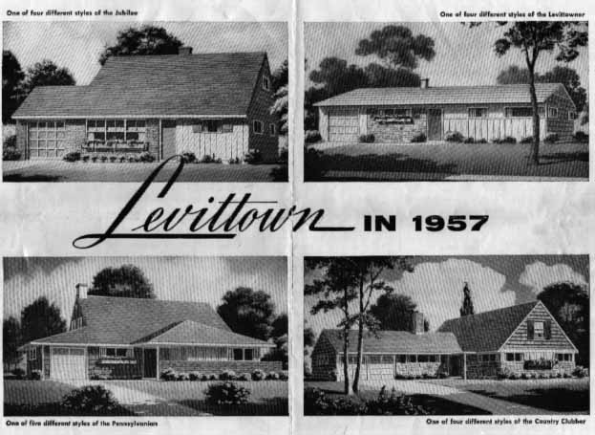
Source 3: The popular song “Little Boxes,” written by Malvina Reynolds in 1962, provides political satire about the development of suburbia and associated conformist middle-class attitudes. Reynolds refers to suburban tract housing as “little boxes made out of ticky-tacky” – a reference to the shoddy material used in the construction of housing of the time. Nancy Reynolds, Malvina’s daughter, explained that her mother came up with the song when she saw the housing developments around Daly City, California, built in the post-war era: “My mother and father were driving South from San Francisco through Daly City when my mom got the idea for the song. When Time magazine (I think, maybe Newsweek) wanted a photo of her pointing to the very place, she couldn’t find those houses because so many more had been built around them that the hillsides were totally covered.” See lyrics below:
Little boxes on the hillside, little boxes made of ticky tacky, little boxes on the hillside, little boxes all the same. There's a green one and a pink one, and a blue one and a yellow one, and they're all made out of ticky tacky, and they all look just the same.
And the people in the houses, all went to the university, where they were put in boxes and they came out all the same, and there's doctors and lawyers, and business executives, and they're all made out of ticky tacky and they all look just the same.
And they all play on the golf course and drink their martinis dry,
and they all have pretty children and the children go to school,
and the children go to summer camp and then to the university,
where they are put in boxes and they come out all the same…
- What image of American culture and society emerges from this song? How does this song express criticism of suburbia and housing developments such as Levittown?

