P8/9 | Cold War (1945-’91): Note Guide Name:
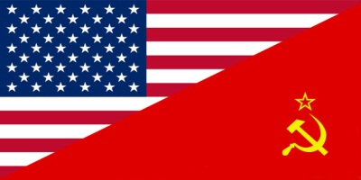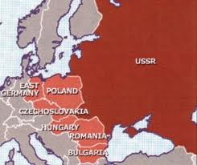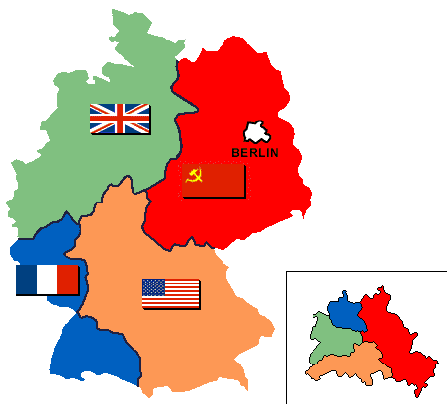

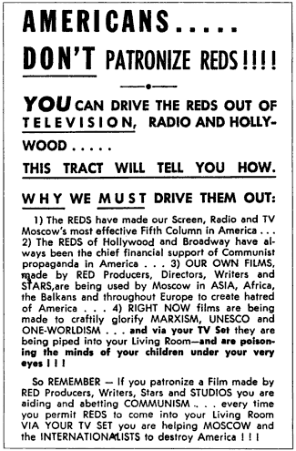
The Narrowing of U.S. Freedom during the Cold War
- Truman argued that national security demanded a substantial increase in the size of the federal government, including military forces and surveillance agencies
- In response to an __________________________ /unstable world, the U.S. narrowed freedoms by suppressing dissent and implementing loyalty oaths to employees
- Within two weeks of proclaiming the Truman Doctrine, the president signed Executive Order 9835 (1947), establishing a loyalty program for all federal employees; the new Federal Employees Loyalty and Security Program, directed at members of the Communist Party, as well as fascists and anyone guilty of “sympathetic association” with either, established a political test for federal employment; it also outlined procedures for investigating current and prospective federal employees
  - Loyalty review boards often asked employees about their opinions on the USSR, the Marshall Plan, or NATO, or if they would report fellow workers if they found out they were Communists
  - An employee could be dismissed merely on “__________________________ grounds” rather than on proof of disloyalty
  - Later amendments added “homosexuals” as potential security risks
- Many state and municipal governments enacted loyalty programs and required public employees, such as teachers, to sign loyalty oaths; in all, some 7 million people underwent loyalty and security checks
- Under Attorney General Tom Clark, a list of hundreds of social organizations deemed hostile to America were stigmatized and liable for investigation and prosecution; groups targeted had no right of appeal; only a handful of organizations had the funds to challenge the listing legally; most simply closed their doors
- In 1950, Congress overrode the president’s veto to pass a bill that Truman called “the greatest danger to freedom of press, speech, and assembly since the Sedition Act of 1798”; the Internal Security (McCarran) Act required Communist organizations to register with the Subversive Activities Control Board and authorized the arrest of suspect persons during a national emergency
- The Immigration and Nationality Act of 1952, over Truman’s veto, barred people deemed “subversive” or “homosexual” from becoming citizens or even visiting the U.S.; it also empowered the attorney general to deport immigrants who were members of Communist organizations, even if they had become __________________________
- The House Un-American Activities Committee (HUAC) investigated alleged disloyalty and subversive activities on the part of private citizens, public employees, and those organizations suspected of having Communist ties (more on this in video below)
- Evaluate the narrowing of freedom during the Cold War:
- Make a course connection between this section and a different historical period:

McCarthyism and the Second Red Scare, 1947-early ‘60s
- Wisconsin Republican Joseph R. McCarthy first won election to the Senate in 1946 during a campaign marked by much anticommunist Red-baiting
- By 1947, the nation was in the throes of another Red Scare, like the one that began following the Bolshevik Revolution in 1917
- McCarthy, in a speech at Wheeling, West Virginia in 1950 (see below) mounted an attack on Truman’s foreign policy agenda by charging that the State Department harbored “traitorous” Communists
- Advance copies of this speech distributed to the press claimed there were 205 Communists in the State Department but McCarthy revised this claim to 57 in a letter to Truman and in the “official” transcript of the speech that McCarthy submitted to the Congressional Record
- McCarthy never made the list public
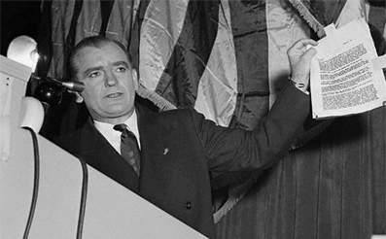
Speech of Joseph McCarthy, Wheeling, West Virginia, 1950
Ladies and gentlemen, tonight as we celebrate the one hundred forty-first birthday of one of the greatest men in American history . . . . Five years after a world war has been won, men’s hearts should anticipate a long peace—and men’s minds should be free from the heavy weight that comes with war. But this is not such a period—for this is not a period of peace. This is a time of “the cold war.” This is a time when all the world is split into two vast, increasingly hostile armed camps—a time of a great armament race.
…There is still a hope for peace if we finally decide that no longer can we safely blind our eyes and close our ears to those facts which are shaping up more and more clearly . . . and that is that we are now engaged in a show-down fight . . . not the usual war between nations for land areas or other material gains, but a war between two diametrically opposed ideologies. The great difference between our western Christian world and the atheistic Communist world is not political, gentlemen, it is moral. For instance, the Marxian idea of confiscating the land and factories and running the entire economy as a single enterprise is momentous. Likewise, Lenin’s invention of the one-party police state as a way to make Marx’s idea work is hardly less momentous. Stalin’s resolute putting across of these two ideas, of course, did much to divide the world. With only these differences, however, the east and the west could most certainly still live in peace. . .
Karl Marx dismissed God as a hoax, and Lenin and Stalin have added in clear-cut, unmistakable language their resolve that no nation, no people who believe in a god, can exist side by side with their communistic state. . . . Today we are engaged in a final, all-out battle between communistic atheism and Christianity. Lest there be any doubt that the time has been chosen, let us go directly to the leader of communism today—Joseph Stalin. Here is what he said—not back in 1928, not before the war, not during the war—but two years after the last war was ended: “To think that the Communist revolution can be carried out peacefully, within the framework of a Christian democracy, means one has either gone out of one’s mind and lost all normal understanding, or has grossly and openly repudiated the Communist revolution.” . . . Ladies and gentlemen, can there be anyone tonight who is so blind as to say that the war is not on? Can there by anyone who fails to realize that the Communist world has said the time is now? . . . that this is the time for the show-down between the democratic Christian world and the communistic atheistic world? Unless we face this fact, we shall pay the price that must be paid by those who wait too long.
Six years ago, . . . there was within the Soviet orbit, 180,000,000 people. Lined up on the antitotalitarian side there were in the world at that time, roughly 1,625,000,000 people. Today, only six years later, there are 800,000,000 people under the absolute domination of Soviet Russia—an increase of over 400 percent. On our side, the figure has shrunk to around 500,000,000. In other words, in less than six years, the odds have changed from 9 to 1 in our favor to 8 to 5 against us. This indicates the swiftness of the tempo of Communist victories and American defeats in the cold war. . . . When a great democracy is destroyed, it will not be from enemies from without, but rather because of enemies from within. . . . The reason why we find ourselves in a position of impotency is not because our only powerful potential enemy has sent men to invade our shores . . . but rather because of the traitorous actions of those who have been treated so well by this Nation. It has not been the less fortunate, or members of minority groups who have been traitorous to this Nation, but rather those who have had all the benefits that the wealthiest Nation on earth has had to offer . . . the finest homes, the finest college education and the finest jobs in government we can give.
This is glaringly true in the State Department. There the bright young men who are born with silver spoons in their mouths are the ones who have been most traitorous. . . . I have here in my hand a list of 205 [later changed to 57] . . . a list of names that were made known to the Secretary of State as being members of the Communist Party and who nevertheless are still working and shaping policy in the State Department. . . .
3. What theme(s) did you notice throughout McCarthy’s speech?

Two Perspectives on the U.S. & the Cold War:
James Henretta (University of Maryland) | Peter Kuznick (American University)
“Behind much of the US foreign policy in the first two decades of the Cold War lay the memory of appeasement. The generation of politicians and officials who designed the containment strategy had come of age in the shadow of Munich, the conference in 1938 at which the Western democracies had appeased Hitler by giving him part of Czechoslovakia, paving the road to WWII. Applying the lessons of Munich, American presidents believed that appeasing Stalin (and subsequent Soviet leaders) would have the same result. Thus in . . . Korea, . . . Vietnam, [etc.] the US staunchly resisted the Soviets—or what it perceived as Soviet influence[,] drawing Americans into armed conflicts—and convinced them to support repressive, right wing regimes—that compromised, as much as supported stated American principles.” | “There is, still today, a fundamental misunderstanding about why the United States entered the Cold War. There is no doubt that the Soviets imposed repressive, and when challenged, brutal dictatorships on Poland, Hungary, Romania, Bulgaria, Albania, East Germany, and Czechoslovakia. But it is equally clear that the Soviets were initially willing to accept governments friendly to them in these countries until the United States began to make threatening moves on both their ideology and their security. During this post-war period, it was the United States with its atomic monopoly, its creation of NATO, its hyper-spending on defense, and its paranoia, which bears the lion’s share of responsibility for starting the Cold War. In all these matters after liberating Western Europe after WWII, the United States was now signaling fear and aggression. Why this fear? We are separated from the rest of the world by two enormous oceans and are still susceptible to fear. Is it necessary to exaggerate the fear of persecution from abroad? We are the most heavily armed nation in the world; but when any nation goes to an extreme degree to protect itself, it’s inevitable that even this amount of protection will never seem psychologically to be enough. It is also often true that the image of the enemy will grow proportionate to the size of the defense, resulting in an overreaction and accelerated spending of energies in a futile attempt to liquidate that fear which never seems to erode. In hindsight, US leaders had exaggerated the threat from an enemy THEY felt THEY needed, wanting to frame the world as an existential clash between two antagonistic social systems.”

- Summarize the key argument from each historian. Compare the two statements. What notable similarities do you see between Henretta and Kuznick? Differences?

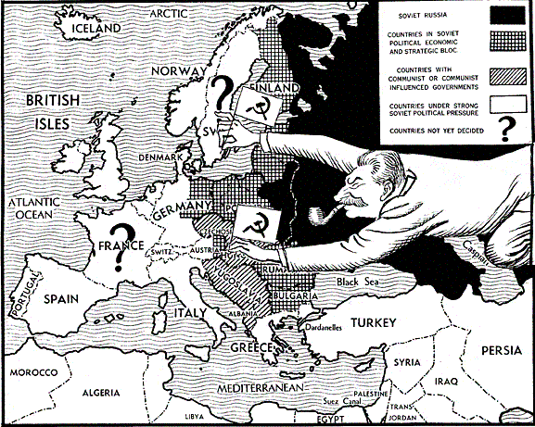
- Have these authors presented a plausible argument that the United States’ actions are mainly to blame for the origin/rise of tensions between itself and the USSR in the early decades of the Cold War? If you agree, explain how the evidence proves this statement. If you disagree, present evidence to the contrary in your response.

