Civil War Politics
 | Leaders | Beliefs | During War | After War
Republicans

Radical Republicans

Peace Democrats/ “Copperheads” 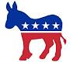

War Democrats

National Union Party

Southern Democrats

