**THIS IS A TRADITIONAL & OPTIONAL ASSIGNMENT… IT MUST BE PRINTED AND COMPLETED IN INK!**

Name:_______________________________________ Class Period:____ Due Date:___/____/____

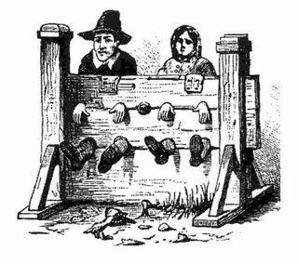Guided Reading & Analysis: Colonial Society

Chapter 3- Colonial Society in the 18th Century, pp 45-55

**Reading Assignment:**

Ch. 3 AMSCO or other resource for content corresponding to Period 2.

**Purpose:**

This guide is not only a place to record notes as you read, but also to provide a place and structure for

*reflections and analysis* using higher level thinking skills with new knowledge gained from the reading.

**Basic Directions:**

1. **Pre-Read:** Read the prompts/questions within this guide before you read the chapter.
2. **Skim:** Flip through the chapter and note the titles and subtitles. Look at images and their

read captions. *Get a feel for the content you are about to read.*

1. **Read/Analyze:** Read the chapter. Remember, the goal is not to “fish” for a specific answer(s) to

reading guide questions, but to ***consider questions in order***

***to critically understand what you read***!

1. **Write**  Write your notes and analysis in the spaces provided.

(Image Source: Colonial Society of Massachusetts,

*History of Crime and Punishment*)

**Key Concepts FOR PERIOD 2:**

**Key Concept 2.1: Europeans** developed a variety of colonization and **migration patterns**, influenced by different **imperial goals**, **cultures**, and the varied North American **environments** where they settled, and they **competed** with each other and **American Indians** for resources.

Key Concept 2.2: The **British colonies** participated in political, social, cultural, and economic exchanges with Great Britain that encouraged both stronger bonds with Britain and resistance to Britain’s control.

**SECTION 1 Guided Reading, pp 45-55**

As you read the chapter, jot down your notes in the middle column. Consider your notes to be elaborations on the Objectives and Main Ideas presented in the left column. When you finish the section, analyze what you read by answering the question in the right hand column.

1. **Population Growth** pp 45-46

|  |  |  |
| --- | --- | --- |
| **Key Concepts &**  **Main Ideas** | **Notes** | **Analysis** |
| **Regional differences developed in the British colonies due to many factors, often creating conflict.**  **European colonization efforts in North America stimulated intercultural contact.** | Population Growth…  European Immigrants…  English…  German…  Scots-Irish…  Other Europeans…  …continued on next page  Africans… | **List 3 main reasons Europeans came to the New World.**  **1.**  **2.**  **3.**  **List 3 main differences between the German and Scots-Irish immigrants.**  **1.**  **2.**  **3.**  **Explain 2 reasons the African immigrants differed from the other groups.**  **1.**  **2.** |

1. **The Structure of Colonial Society,** p 47

|  |  |  |
| --- | --- | --- |
| **Key Concepts & Main Ideas** | **Notes** | **Analysis** |
| **Cultural diversity contributed to the development of regional differences as well as a new identity.** | General Characteristics…  Self-Government…  Religious Toleration…  No Hereditary Aristocracy…  Social Mobility…  The Family…  Men…  Women… | **List three major ways identity and way of life in the colonies differed from England.**  **1.**  **2.**  **3.**  **List three ways colonial society differed from modern day society.**  **1.**  **2.**  **3.** |

1. **The Economy**, p48

|  |  |  |
| --- | --- | --- |
| Key Concepts & Main Ideas | Notes | Analysis |
| **Along with other factors, environmental and geographical variations, including climate and natural resources, contributed to regional differences.**    **Along with other factors, environmental and geographical variations, including climate and natural resources, contributed to regional differences.** | The Economy…  …continued on next page  New England…  Middle Colonies…  Southern Colonies…  Monetary System…  Transportation… | **How did Britain influence the developing colonial economy?**  **What do all three regions have in common economically?**  **How did transportation impact colonial regions differently?** |

1. **Religion**, pp 49-50

|  |  |  |
| --- | --- | --- |
| Key Concepts & Main Ideas | Notes | Analysis |
| **Britain’s desire to maintain a viable North American empire in the face of growing internal challenges and external competition inspired efforts to strengthen its imperial control, stimulating increasing resistance from colonists who had grown accustomed to a large measure of autonomy.** | Religion…  Challenges…  Established Churches…  The Great Awakening…  Jonathan Edwards…  George Whitefield…  Religious Impact…  Political Influence… | Explain why there was so much conflict between and among so many religious groups.  Defend the following statement with 3 pieces of evidence: The spirit of rebellion responsible for the American Revolution began in the First Great Awakening.  1.  2.  3. |

1. **Cultural Life**, pp 50-53

|  |  |  |
| --- | --- | --- |
| Key Concepts & Main Ideas | Notes | Analysis |
| **Many factors contributed to regional differences.**  **Over time the colonies began to develop unique identity.**  **Britain’s desire to maintain a viable North American empire in the face of growing internal challenges and external competition inspired efforts to strengthen its imperial control, stimulating increasing resistance from colonists who had grown accustomed to a large measure of autonomy.**  **The political thought of the Enlightenment and greater religious independence and diversity created conflict between Britain and her colonies.**  **Over time the colonies began to develop unique identity.** | Cultural Life…  Achievements in the Arts and Sciences…  Architecture…  Painting…  Literature…  Science…  Education…  Elementary Education…  Higher Education…  Ministry…  Physicians…  Lawyers…  The Press…  Newspapers…  The Zenger Case…  Rural Folkways…  …continued on next page  The Enlightenment…  Emergence of a National Character… | How “American” was colonial art?  To what extent does it illustrate the development of a new/different society?  Compare the importance and opportunity of education in the North to that in the South. Why were these two regions so different when it came to education?  Compare the social hierarchy of ministers, doctors, and lawyers in the colonial era to the modern era. Why the change?  List/Describe three ways the press influenced the development of the American identity.  1.  2.  3.  How did the Enlightenment threaten the English empire? |

1. **Politics**, pp 54-55

|  |  |  |
| --- | --- | --- |
| Key Concepts & Main Ideas | Notes | Analysis |
| **The increasing political, economic, and cultural exchanges within the “Atlantic World” had a profound impact on the development of colonial societies in North America.**  **Britain’s desire to maintain a viable North American empire in the face of growing internal challenges and external competition inspired efforts to strengthen its imperial control, stimulating increasing resistance from colonists who had grown accustomed to a large measure of autonomy.** | Politics…  Structure of Government…  Local Government…  Voting… | **Explain how and why colonies of the world’s most powerful empire developed unique, independent system of governing.**  **Read Historical Perspectives on page 55. Which viewpoint do you agree with the most? Explain your choice.** |

**Section 2: HIPP**

“On Being Brought from Africa to America”

**H**istorical Context:

**I**ntended Audience:

Author’s **P**urpose:

Author’s **P**oint of View:

“‘Twas mercy brought me from my pagan land

Taught my benighted soul to understand

That there’s a God, that there’s a savior, too;

Once I redemption neither sought nor knew.

Some view our sable race with scornful eye,

‘Their color is a diabolic lie.’

Remember, Christians, Negroes black as Cain

May be refined and join the angelic train.”

(1766, **Phillis Wheatley**)

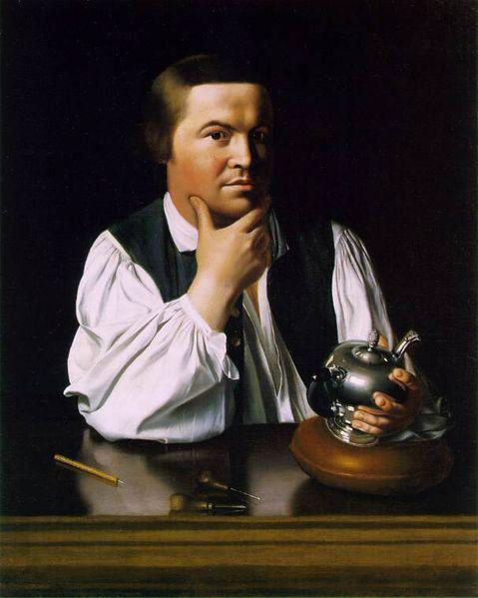

🡨**John Singleton Copley** was a very talented painter who went abroad to help develop his skills, like most painters had to do. One of his most famous paintings is this portrait of Paul Revere.

**John Trumbull** also studied in Europe, and he did paint many of our founders. The signing of the Declaration of Independence is one of his most famous pieces.

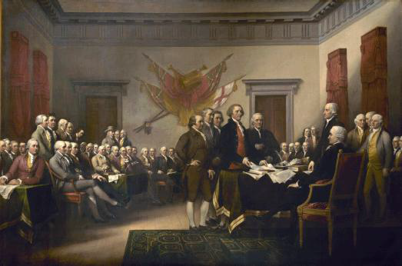

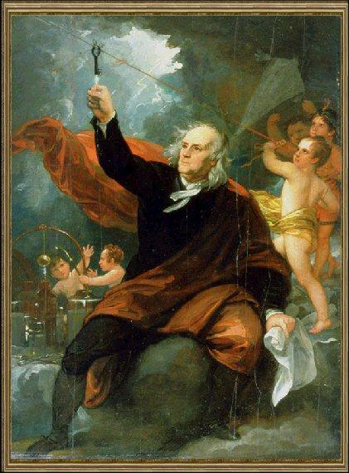



**Charles Wilson Peale** was one of the best-known American painters of the eighteenth century and one of the few to make his career in the United States rather than Europe. Originally apprenticed as a saddler, he was forced out of that trade because he joined the Sons of Liberty and most of his customers were Loyalists. He then became interested in art and studied under John Singleton Copley in Boston and **Benjamin West** in London. West painted *Franklin Drawing Lightning from the Sky 🡪*

🡨Peale painted Washington seven times, including this portrait.

How would you characterize American art based on these examples? Think **HIPP**!

**H**istorical Context:

**I**ntended Audience:

Author’s **P**urpose:

Author’s **P**oint of View:

**Reading Guide written by Rebecca Richardson, Allen High School**

Sources include but are not limited to: 2015 edition of AMSCO’s *United States History Preparing for the Advanced Placement Examination*, Wikipedia.org, College Board Advanced Placement

United States History Framework, writing strategies developed by Mr. John P. Irish, Carroll High School, 12th edition of *American Pageant, USHistory.org, Britannica.com,*

*and other sources as cited in document and collected/adapted over 20 years of teaching and collaborating..*