**THIS IS A TRADITIONAL & OPTIONAL ASSIGNMENT… IT MUST BE PRINTED AND COMPLETED IN INK!**

Name:_______________________________________ Class Period:____ Due Date:___/____/____

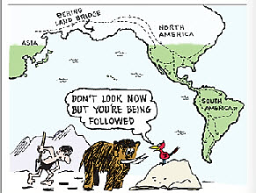

Guided Reading & Analysis: A New World

Chapter 1- A New World of Many Cultures, 1491-1607, pp 1-13

**Purpose:**

This guide is not only a place to record notes as you read, but also to provide a place and structure for

*reflections and analysis* using your noggin (thinking skills) with new knowledge gained from the

reading. This guide, **if completed *in its entirety* BOP (Beginning of Period) by the due date**, can be

used on the first quiz as well as earn up to 10 bonus points. The benefits of such activities, however,

go far beyond quiz help and bonus points. ☺ **Mastery of the course and AP exam await all who**

**choose to *process* the information as they read/receive**. This is an optional assignment.

**So… young Jedi… what is your choice? Do? Or do not? There is no try.**

(Image Source: *AdventureTales.com*)

**Directions:**

1. **Pre-Read:** Read the prompts/questions within this guide before you read the chapter.
2. **Skim:** Flip through the chapter and note titles and subtitles. Look at images and read captions. *Get a feel for the content you are about to read.*
3. **Read/Analyze:** Read the chapter. If you have your own copy of AMSCO, Highlight key events and people as you read. Remember, the goal is not to “fish” for a

specific answer(s) to reading guide questions, but to ***consider questions in order to critically understand what you read***!

1. **Write**  Write your notes and analysis in the spaces provided OR complete digitally on Canvas. If you are completing paper copy, complete it in ***INK!***

**Key Concepts FOR PERIOD 1:**

***NOTE: College Board released revisions to the APUSH framework July of 2015. The key concepts and objectives addressed in your texts reflect the 2014 version of the framework. This guide includes the 2015 revisions to the key concepts. In general, the expectations are not that different. College Board simply sought to clarify and simplify the expectations.***

**Key Concept 1.1:** As **native populations** migrated and settledacross the vast expanse of North America over time, they developed distinct and increasingly **complex societies** by adapting to and transforming their diverse environments.

**Key Concept 1.2:** Contact among **Europeans, Native Americans, and Africans** resulted in the **Columbian Exchange** and significant social, cultural, and political changes on both sides of the Atlantic Ocean.

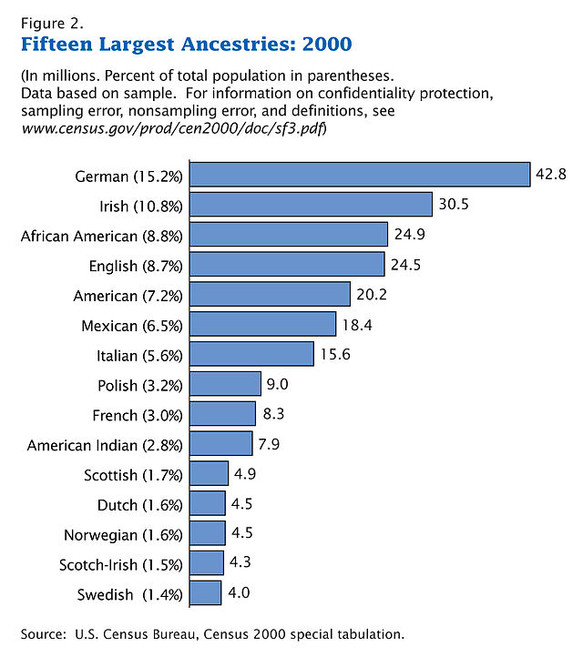SECTION 1 - Period Perspectives, p.1

Consider the data in the chart at right as well as page 1 of

the text when completing this section.

1. Period 1 begins with 1491. If the American Indian population in

what is now the United States was nearly 10 million before 1492,

why is the United States population in modern times only 2 to 3%

American Indian?

1. Period 1 ends with the establishment of Jamestown, the first

permanent British settlement in North America. Explain why

1607 is a major turning point in United States history.

**SECTION 2 Guided Reading, pp 2-13**

As you read the chapter, jot down your notes in the middle column. Consider your notes to be elaborations on the Objectives and Main Ideas presented in the left column. When you finish reading the section and taking notes, process and analyze what you read by answering the question in the right hand column. You do not need to write in complete sentences.

1. **Cultures** pp 2-5

|  |  |  |
| --- | --- | --- |
| **Key Concepts &**  **Main Ideas** | **Notes** | **Analysis** |
| **Before the arrival of Europeans, native populations in North America developed a wide variety of social, political, and economic structures based in part on interactions with the environment and each other.**  **As settlers migrated and settled across the vast expanse of North America over time, they developed quite different and increasingly complex societies by adapting to and transforming their diverse environments.** | **Cultures of Central and South America…**  **Cultures of North America…**  **Language…**  **Southwest Settlements…**  **Northwest Settlements…**  **Great Plains…**  **Midwest Settlements…**  **Northeast Settlements…**  **Atlantic Seaboard Settlements…** | ***In what ways* did native peoples *transform* North American environment before European colonization? (list)**  a.  b.  c.  d.  **Identify one *key similarity* and one *key difference* between societies that developed in Central and South America to those that developed in North America.**  Similarity:  Difference:  **Explain the significance of the *difference* between Central /South America and North America.** |

1. **Europe Moves Toward Exploration,** pp 5-6

|  |  |  |
| --- | --- | --- |
| **Key Concepts & Main Ideas** | **Notes** | **Analysis** |
| **New technology, new knowledge, and new goals spurred European exploration.** | **Improvements in technology…**  **Religious conflict…** | **Identify the *key difference* between Viking voyages of the 12th century to that of Columbus in the 15th century.**  ***How* did new technology enable Christopher Columbus to dominate the “New World?”**  **What was the *impact* of the Catholic victory in Spain and the European Reformation on North America?** |

1. **Expanding Trade**, pp 6-7

|  |  |  |
| --- | --- | --- |
| **Key Concepts & Main Ideas** | **Notes** | **Analysis** |
| **Economic motives drove exploration, and “discovery” altered the European, African, and America economically, politically, and culturally.** | **New Routes…**  **Slave Trading…**  **African Resistance…**  **Developing Nation-States…** | **List *three main effects* of Europe’s expanding trade in the 15th century.**  a.  b.  c.  **Which effect was *most significant*? Explain your answer.** |

1. **Early Explorations**, pp 7-10

|  |  |  |
| --- | --- | --- |
| **Key Concepts & Main Ideas** | **Notes** | **Analysis** |
| **European overseas expansion resulted in the Columbian Exchange, a series of interactions and adaptations among societies across the Atlantic.**   1. **The arrival of Europeans in the Western Hemisphere in the 15th and 16th centuries triggered extensive demographic and social changes on both sides of the Atlantic.**   **European expansion into the Western Hemisphere caused intense social/religious, political, and economic competition in Europe and the promotion of empire building.** | **Christopher Columbus…**  **Columbus’s Legacy…**  **Exchanges…**  **Dividing the Americas…**  **Spanish Exploration and Conquest…**  **English Claims…**  **French Claims…**  **Dutch Claims…** | ***How* did European expansion *impact* European society?**  ***How* did European expansion *impact* Native American society?**  **Which of these consequences were the most significant? Explain your answer.** |

1. **Spanish Settlements in North America**, pp 10-11

|  |  |  |
| --- | --- | --- |
| **Key Concepts & Main Ideas** | **Notes** | **Analysis** |
| **European expansion into the Western Hemisphere caused intense social/religious, political, and economic competition in Europe and the promotion of empire building.** | **Florida…**  **New Mexico…**  **Texas…**  **California…** | **What were *three* *chief features* of the Spanish empire in America?**  a.  b.  c.  **Identify *one cause* and *one effect* of Spanish settlement in North America.**  Cause:  Effect: |

1. **European Treatment of Native Americans**, pp 11-12

|  |  |  |
| --- | --- | --- |
| **Key Concepts & Main Ideas** | **Notes** | **Analysis** |
| **Contacts among American Indians, Africans, and Europeans challenged the worldviews of each group.**  **European overseas expansion and sustained contacts with Africans and American Indians dramatically altered European views of social, political, and economic relationships among and between white and nonwhite peoples** | **Spanish Policy…**  **English Policy…**  **French Policy…**  **Native American Reaction…** | **Identify *three major consequences* of European contact with American Indians?**  a.  b.  c.  **Which of these were the *most significant*? Explain your answer.**  **In what ways was English policy toward Native Americans different from those of France and Spain?**  *Different from France in that…*  *Different from Spain in that…*  ***How* *effective* were Native Americans in overcoming the negative aspects of European policies?** |

1. **Historical Perspectives: Was Columbus a Great Hero?** p.13

|  |  |  |
| --- | --- | --- |
| **Key Concepts & Main Ideas** | **Notes** | **Analysis** |
| **European overseas expansion and sustained contacts with Africans and American Indians dramatically altered European views of social, political, and economic relationships among and between white and nonwhite peoples.** | **Washington Irving…**  **President Franklin Roosevelt…**  **Revisionists…**  **Arthur Schlesinger…**  **Fact and fiction…** | **Support or refute the following statement: Christopher Columbus was a hero.**  **List 3 pieces of evidence to support your answer.**  a.  b.  c.  **List 3 pieces of evidence that support the alternate view.**  a.  b.  c. |

1. 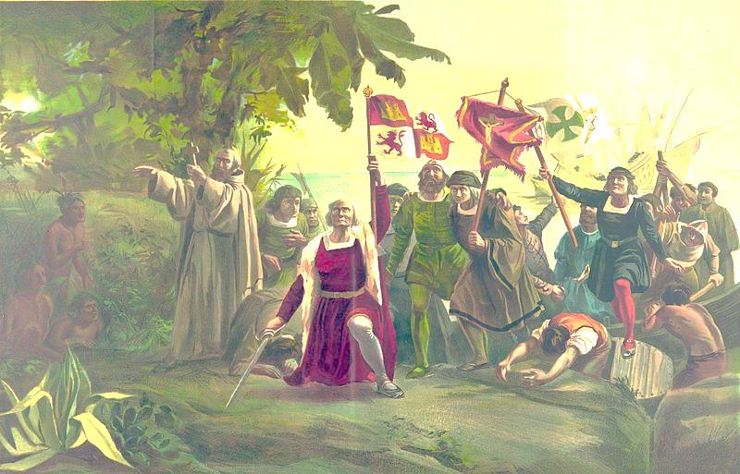**Explain the HIPP of the image below.**

Image Source: Public Domain, Library of Congress,

*First landing of Columbus on the shores of the*

*New World, at San Salvador, W.I., Oct. 12th 1492*,

Dióscoro Teófilo Puebla Tolín

**HIPP+:**

**H**istorical Context:

**I**ntended Audience:

Author’s **P**urpose:

Author’s **P**oint of View:

**+**Other Context (*similar in kind, from a different time*…give an example of similar theme in a different place/time period):

**Section 3 MAP**

The College Board framework for the course includes specific places and locations significant to the development of North America and the United states. This section provides you with the opportunity to locate and review these items.

Directions:

1. Read the framework excerpts located to the right of the map, and ensure you *understand & know* where/what is referenced.
2. Circle or highlight the following groups: Pueblo, Chinooks, Iroquois, Algonquian, Wamponoags, Pequot, Powhatan
3. Label/Trace the starting point and expansion of maize cultivation.

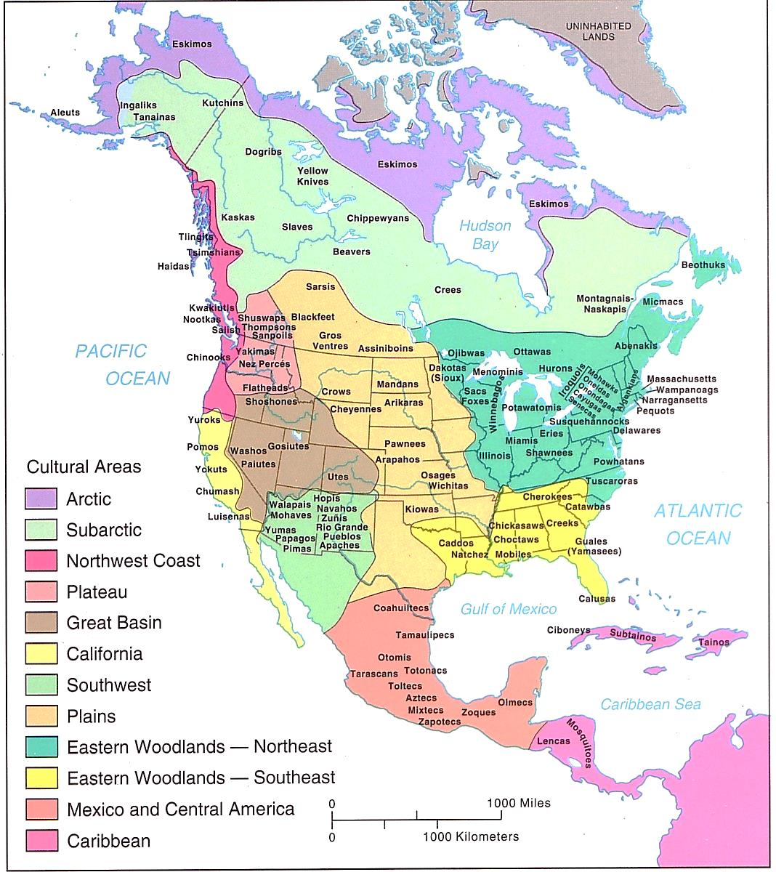

***On a North American continent…*** *The spread of* ***maize*** *cultivation from* ***present-day Mexico*** *northward into the* ***American Southwest*** *and beyond supported economic development and social diversification among societies in these areas; a mix of foraging and hunting did the same for societies in the* ***Northwest*** *and areas of* ***California****.*

*Societies responded to the lack of natural resources in the* ***Great Basin*** *and the* ***western Great Plains*** *by developing largely mobile lifestyles.*

*In the* ***Northeast*** *and along the* ***Atlantic Seaboard*** *some societies developed a mixed agricultural and hunter–gatherer economy that favored the development of permanent villages.*

*European overseas expansion resulted in the* ***Columbian Exchange****, a series of interactions and adaptations among societies across the* ***Atlantic****. The arrival of Europeans in the* ***Western Hemisphere*** *in the 15th and 16th centuries triggered extensive demographic and social changes on both sides of the* ***Atlantic****.*

Source: North American Continent; Western Hemisphere Indian Culture Map, http://lochgarry.wordpress.com/2011/11/27/ancient-winds-and-memories-of-a-time-long-ago/

**Reading Guide written by Rebecca Richardson, Allen High School**

Sources include but are not limited to: 2015 edition of AMSCO’s *United States History Preparing for the Advanced Placement Examination*, Wikipedia.org, College Board Advanced Placement

United States History Framework, writing strategies developed by Mr. John P. Irish, Carroll High School, 12th edition of *American Pageant, USHistory.org, Britannica.com,*

*LatinAmericanHistory.about.com, and other sources as cited in document and collected/adapted over 20 years of teaching and collaborating.*