P8 | APUSH | Brown v. Board of Education (1954), D___ Name:
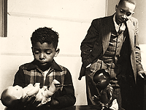
Brown v. Board of Education (1954) is acknowledged as one of the greatest Supreme Court decisions of the 20th century. The Court held that racial segregation of children in public schools violated the Equal Protection Clause of the 14th Amendment. Although the decision did not succeed in fully desegregating public education in the U.S., it put the Constitution on the side of racial equality and was an early victory in the Civil Rights Movement, which helped galvanize more activists for its cause.
We’ll begin by looking at a study that was used in the landmark case: the Clark Doll Experiments.
The Clark Doll Experiments, excerpted from the NAACP’s “Doll Test” tribute:
In the 1940s, psychologists Kenneth and Mamie Clark designed and conducted a series of experiments known as “the doll tests” to study the psychological effects of segregation on African American children. Drs. Clark used dolls, identical except for color, to test children’s racial perceptions. Their subjects, children between the ages of three to nine, were asked to identify both the race of the dolls and which color doll they prefer. The children overwhelmingly preferred the white doll and assigned positive characteristics to it. The Clarks concluded that “prejudice, discrimination, and segregation” created a feeling of inferiority among African American children and damaged their self-esteem. In the 1954 Brown v. Board of Education case, the experiment helped to persuade the U.S. Supreme Court that “separate but equal” was inherently unequal. The Supreme Court acknowledged the experiments implicitly in the following passage: “To separate [African-American children] from others of similar age and qualifications solely because of their race generates a feeling of inferiority as to their status in the community that may affect their hearts and minds in a way unlikely ever to be undone.”
In an interview on the award-winning PBS documentary of the Civil Rights movement, “Eyes on the Prize,” Dr. Kenneth Clark recalled: "The Dolls Test was an attempt on the part of my wife and me to study the development of the sense of self-esteem in children. We worked with black children to see the extent to which their color, their sense of their own race and status, influenced their judgment about themselves, self-esteem. This research, by the way, was done long before we had any notion that the NAACP or that the public officials would be concerned with our results. In fact, we first did the study fourteen years before Brown, and the lawyers of the NAACP learned about it and came and asked us if we thought it was relevant to what they were planning to do in terms of the Brown case. And we told them it was up to them to make that decision and we did not do it for litigation. We did it to communicate to our colleagues in psychology the influence of race and color and status on the self-esteem of children." In a particularly memorable episode while Dr. Clark was conducting experiments in rural Arkansas, he asked a black child which doll was most like him. The child responded by smiling and pointing to the brown doll: "That's a nig**r. I'm a nig**r." Dr. Clark described this experience "as disturbing, or more disturbing, than the children in Massachusetts who would refuse to answer the question or who would cry and run out of the room."
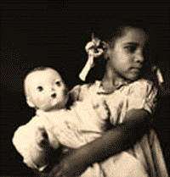
In the experiment, the psychologists would show the black children two dolls, one white and one black, and then ask these questions in this order:
- “Show me the doll that you like best or that you’d like to play with,”
- “Show me the doll that is the ‘nice’ doll,”
- “Show me the doll that looks ‘bad’,”
- “Give me the doll that looks like a white child,”
- “Give me the doll that looks like a colored child,”
- “Give me the doll that looks like a Negro child,”
- “Give me the doll that looks like you,”
- “Show me the pretty doll.”
The last two questions were often the most difficult, since by that point, most black children had picked the black doll as the bad one. In 1950, 44% said the white doll looked like them! In past tests, however, many children would refuse to pick either doll or just start crying and run away.
The Clarks conducted their studies across the country; they found that black children who went to segregated schools, those separated by race, were more likely to pick the white doll as the nice one. Clark also asked children to color a picture of themselves. Most chose a shade of brown markedly lighter than themselves.
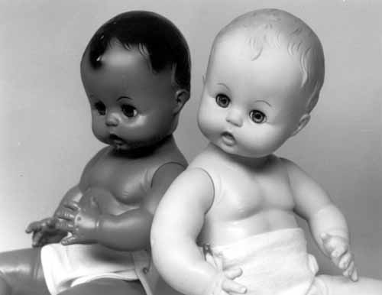
Although Dr. Kenneth Clark is most famous for the "Doll Tests," his personal achievements are equally as prestigious. He was the first African American to earn a PhD in psychology at Columbia and serve as president of the American Psychological Association. His wife Mamie Clark was the first African American woman and the second African American, after Kenneth Clark, to receive a doctorate in psychology at Columbia. In 1946, the Clarks founded the Northside Center for Child Development in Harlem, where they conducted experiments on racial biases in education. The Clarks also created Harlem Youth Opportunities Unlimited (HARYOU) in 1962, which was later endorsed by then Attorney General Robert F. Kennedy and President Lyndon B. Johnson, whose administration helped finance the program. HARYOU recruited educational experts from the top universities in the country to better structure Harlem schools, provide resources and personnel for preschool programs and after-school remedial education, and reduce unemployment among blacks who had dropped out of school.
In 2005, psychologist Kiri Davis repeated the experiment in Harlem as part of her short film, “A Girl Like Me.” 71% of the children surveyed told her that the white doll was the nice one.
Commentary from a black American, 2009: “That happened to me once. When I was a little girl, grandma took me to Toys R Us to get a doll. A black girl showed me and my grandma where the dolls were and they had them on a shelf, one side with the black dolls the other with the white ones, and the black girl handed me the black doll and I put the black doll back and took the blond/blue-eyed doll. I still have that doll and I took it everywhere with me. We even went to visit a slave plantation and I took the doll with me. It didn’t occur to me until years later how messed up that was that I didn’t want the black doll. To this day I wonder would I have loved that black doll as much I did my white doll…”
- What is your reaction to the Clark study and related video (see teacher site for 21st Century Doll Test)? What do you think accounts for Davis’s 2005 findings and results from the recent video? What can/should be done about this issue?

- How would you answer question h? (this is a rhetorical question – but please – have an honest conversation with yourself)
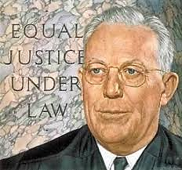
Review of Plessy v. Ferguson (1896) & its Aftermath:
In Plessy, the Supreme Court upheld a Louisiana Jim Crow law that had been challenged by Homer Plessy. The Court argued that there was no attempt to destroy the legal equality of the two races when endorsing or legally enforcing segregation; therefore, recognition and distinction of white men as distinguished from the other races, was constitutional. In Justice Brown’s majority opinion the Court agreed that “the object of the 14th Amendment was undoubtedly to enforce the absolute equality of the two races before the law, but in the nature of things it could not have been intended to abolish distinctions based upon color, or to enforce social, as distinguished from political, equality. . . . If one race be inferior to the other socially, the Constitution of the United States cannot put them upon the same plane.” [Emphasis added.] The sole dissent came from Justice Harlan who claimed that “our Constitution is color-blind” and neither knows nor tolerates classes among citizens. He predicted that further aggressions would occur if the Court admitted separate rights for separate races. Like the law of slavery, the law of segregation fixed a system of identity that marked a person either as white or as not white. The simple dichotomy incorporated notions of white supremacy and racial purity. It made white the standard and made anything less than white substandard and separate.
Justice Harlan accurately predicted further aggressions. The Jim Crow laws enforced segregation of blacks and other people of color from many of the facilities enjoyed by white citizens across much of the United States. Public schools, transportation facilities, residential neighborhoods, public and private theaters, restaurants, and even public lavatories and drinking fountains were designated for the exclusive use of whites, while separate facilities were set aside for “coloreds.” Any hope of changing these laws through democratic processes was stripped away as states erected legal barriers to the exercise of the vote by black citizens (poll taxes, literacy tests, grandfather clauses). And in courthouses across the land, blacks were systematically excluded from service on juries.
A group of individuals committed to fighting against the brutalities of Jim Crow America formed the National Association for the Advancement of Colored People (NAACP) in the Progressive Era (W.E.B. DuBois was one of its founders). Leaders of the NAACP were black attorneys who focused their energies on chipping away at the various mechanisms fortifying the legal system of segregation. All white-jury pools, covenants that restricted ownership of property in certain neighborhoods by race, laws disenfranchising black voters, and segregated graduate schools were all challenged, sometimes successfully. Attention then turned to the politically charged arena of public school segregation. By 1950, the NAACP resolved that nothing other than education of all children on a nonsegregated basis would be an acceptable outcome.
Brown v. Board of Education (1954):
The case known as Brown v. Board of Education actually included appeals from decisions in four separate states, each sponsored by the NAACP: Kansas, Delaware, South Carolina and Virginia. Each case represented individual acts of courage by families willing to face local resistance and hostility to bring an end to segregation. The four cases were argued on appeal to the Supreme Court, with the issue being whether segregation deprived students of equal protection under the 14th Amendment (“no state shall…deny to any person within its jurisdiction the equal protection of the laws”).
Chief Justice Warren (pictured right) wrote the majority opinion for the Court: “In approaching this problem, we cannot turn the clock back to 1868 when the 14th Amendment was adopted, or even to 1896 when the Plessy decision was written.” According to the Court, it had to “consider public education in light of its full development and its present place in American life throughout the Nation. . . . To separate children from others of similar age and qualifications solely because of their race generates a feeling of inferiority as to their status in the community that may affect their hearts and minds in a way unlikely ever to be undone. . . .[I]n the field of public education the doctrine of separate but equal has no place. Separate educational facilities are inherently unequal.” [Emphasis added.] The key holding of the Court was that even if segregated black and white schools were of equal quality in facilities and teachers, segregation by itself was harmful to black students. Through new social science evidence, they found that a significant psychological and social disadvantage was given to black children from the nature of segregation itself.
The Court also declared that racial segregation in schools was a violation of the Equal Protection Clause of the 14th Amendment: “Does segregation of children in public schools solely on the basis of race, even though the physical facilities and other “tangible” factors may be equal, deprive the children of the minority group of equal education opportunities? We believe that it does. . . . Segregation of white and colored children in public schools has a detrimental effect upon the colored children. The impact is greater when it has the sanction of the law, for the policy of separating the races is usually interpreted as denoting the inferiority of the negro group. A sense of inferiority affects the motivation of a child to learn. Segregation with the sanction of law, therefore, has a tendency to retard the educational and mental development of negro children and to deprive them of some of the benefits they would receive in a racial[ly] integrated school system. . . . We conclude that, in the field of public education, the doctrine of "separate but equal" has no place. Separate educational facilities are inherently unequal. Therefore, we hold that the plaintiffs and others similarly situated for whom the actions have been brought are, by reason of the segregation complained of, deprived of the equal protection of the laws guaranteed by the Fourteenth Amendment.”
The unanimous Brown decision didn’t specify how, or how quickly, desegregation was to be achieved in the thousands of segregated schools systems. The NAACP had urged desegregation to proceed immediately or at least within firm deadlines. The Court, fearful of hostility or even violence from a disapproving public, embraced a more flexible solution. The Court delegated the task of carrying out school desegregation to district courts with orders that desegregation occur with “all deliberate speed.” Supporters of the decision were displeased with the action plan, which was regarded as too ambiguous to ensure reasonable haste for compliance with the Court’s instruction. Many Southern states and school districts interpreted the decision as legal justification for resisting, delaying and avoiding significant integration for years—using such tactics as closing down school systems, using state money to finance segregated “private” schools, and “token” integration where a few carefully selected black children were admitted to former white-only schools. Yet the vast majority of black children remained in underfunded, unequal black schools.
Opposition to Brown was severe across the nation and in Congress (see “Impeach Earl Warren” pin to the right); in 1956, over a hundred congressmen signed the Southern Manifesto, which encouraged school districts to undermine and reverse the Court’s ruling and draw school lines in such a way that segregation would continue. This case also marks the point where the Confederate flag started being resurrected to champion the cause of segregation.
By 1964, a decade after the decision, less than 2% of formerly segregated school districts had experienced any desegregation.
- Key Points from Plessy (1896) | Key Points from Brown (1954)
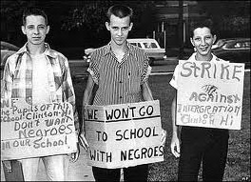
Crisis at Little Rock (1957) & Beyond:
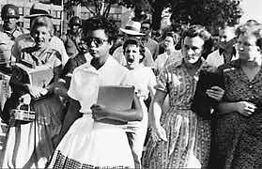
Little Rock Central High School in Arkansas was supposed to be desegregated by the beginning of the 1957 school year. On September 2, the night before the first day of school, Governor Faubus ordered the Arkansas National Guard to monitor the school. The next day, the Guardsmen prevented nine black children from entering the school. On September 20, a Federal District Court issued an injunction that prevented Governor Faubus from using the National Guard to deny black admittance to Central High. When the nine students returned to the school, however, police removed them for their own protection after a mob of 1,000 people around the school grew unruly and violent towards the students. President Eisenhower, despite his open disagreement with the Brown decision, intervened, sending 1,000 paratroopers and 10,000 National Guardsmen to Little Rock. The school was finally desegregated on September 25, 1957.
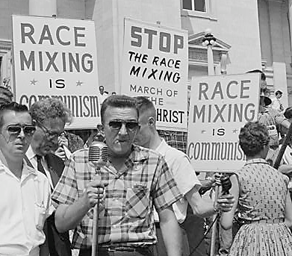
Several years later, Congress and President Johnson intervened to incentivize desegregation by providing a provision in the Civil Rights Act of 1964 that denied federal financial education assistance to schools that failed to desegregate. This encouraged some “token” integration. Yet one problem that remained across the country was de facto segregation; a situation in which schools are attended predominantly by one race, due to the racial composition of the neighborhoods served by those schools. Black leaders in these areas held the belief that where a school is attended predominantly by blacks, despite the cause, the ill effects the Court spoke of in the Brown decision were still produced, particularly because these schools ended up being far inferior to white schools (inadequate resources, teachers, after-school programs, etc.). They therefore concluded that the equal protection clause of the fourteenth amendment compelled the integration of the public schools to correct de facto segregation. When some federal courts found evidence that schools were constructed and school district lines drawn intentionally to segregate the schools racially, some courts ordered racial integration by way of busing. In the 1970s and 1980s, many school districts implemented mandatory busing plans within their districts; such plans often met stiff resistance, particularly when whites were bused to “black” schools and saw what limited opportunities existed there, but also when blacks were bussed to “white” schools and faced regular harassment and intimidation from students. The unpopular practice ended by the early 1990s.
Comments on posters from this page: “Race mixing is communism”
“Strike against integration”
“We won’t go to school with negroes”
By the turn of the century, the experiment with court-ordered desegregation had effectively ended, largely a failure, as de facto segregation continues to be a reality across the country. Yet the Brown decision certainly had a positive impact. The decision contributed to the civil rights movement by giving important support to the movement’s moral claims. Furthermore, if the Court had not made the decision, Congress/the president would have had less impetus to act against segregation at all. It also changed the Supreme Court’s image from that of a conservative institution whose primary political function was to obstruct reform (such as when it routinely blocked strikes, unions, child labor laws, etc.) to one that could be relied on to promote justice.
- White students today typically attend majority white schools; they are more likely today, than in 1954, to attend schools with some (typically minimal) levels of diversity (black, Hispanic, and Asian students)
- Black students today typically attend majority black schools; they are more likely today, than in 1954, to attend schools with some (typically minimal) levels of diversity (white, Hispanic, and Asian students)
- Factors such as de facto segregation and “white flight” have kept our nation’s schools [on average] largely segregated; psychologists and educational experts say this is detrimental to the learning of both black and white students
- What is your reaction to the Little Rock Nine and its aftermath, including the related video (see teacher site)?
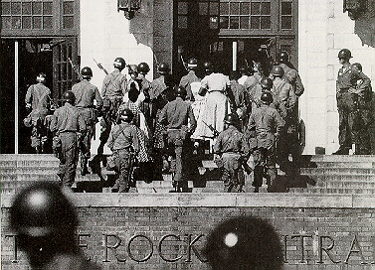
- Do you think the Court made the right decision in Brown v. Board of Education? Were the justices ruling by way of morals or the Constitution? Was it acceptable for them to use psychological evidence to support their decision? Did they justify their claims well enough?

- Reaction to this decision, even in its ambiguity, was fierce in the Southern states (Southern Manifesto, resurrection of the Confederate flag, “Impeach Warren” movement, etc.). What do you think the result would have been had the Court demanded immediate desegregation?

- What does the incident at Little Rock demonstrate about the “power” of the Court? Use your knowledge of the Brown v. Board decision to assess the validity of the statement that follows: “The Executive not only dispenses the honors, but holds the sword of the community. The legislature not only commands the purse, but prescribes the rules by which the duties and rights of every citizen are to be regulated. The judiciary, on the contrary, has no influence over either the sword or the purse. . . . It may truly be said to have neither FORCE nor WILL, but merely judgment.” – Alexander Hamilton in the Federalist Papers, No. 78.

- Many studies show that students benefit, both academically and personally, from an education in a multicultural environment; that the Socratic model of learning by dialogue across similarities and differences of belief, theory, experiences, race, ethnicity, etc., enhances one’s ability to reason, collaborate, problem-solve, and think critically and empathetically. On average, students in multicultural learning environments (from elementary to graduate and professional schools) make larger academic improvements over time and find more joy in their learning. For this reason, many colleges and universities prefer to build racially, ethnically, and religiously diverse student bodies; they recognize the educational value of diversity and view student and faculty diversity as an essential resource for optimizing teaching and learning. Should universities be permitted to continue using race as a consideration in the admission process? You might also think about some of the other considerations colleges make with regards to diversity—ethnicity, religion, socio-economic class, etc. Are these appropriate considerations?

