AP U.S. History
Period Five, 1844-1877
Unit EQ: How do we acquire and maintain democracy in order to maintain/create a more perfect union?
Required Reading: Henretta Chapters 12, 13, 14 &15 & AMSCO Chapters 12, 13, 14 & 15
& Howard Zinn Chapters 8&9
Unit Test Dates: Wednesday, January 17 and DBQ Thursday, January 18. Makeups: Thursday, January 19 AFTERSCHOOL 2-3PM
Recommendations: Reading the textbook is a must. In addition to the textbook reading, there are some recommended strategies to use in addition to the text. Choose one, two or all. Some are even worth Bonus Points on the exam. AMSCO READING GUIDES ARE ON THE WEBSITE UNDER AMSCO READING GUIDES. THEY ARE OPTIONAL BUT HIGHLY RECOMMENDED. THEY MUST BE TURNED IN ON THE DAY OF THE EXAM FOR BONUS POINTS.

Outside Strategies for unit content acquisition:
Quizlet Cengage Lecture Point Completing Reading guides with AMSCO Jocz Youtube Vids
Reading AMSCO Schmoop Watching/Listening to Gilder-Lerhman Review Ramirez website
Crash Course Videos Study Groups Hippocampus

HENRETTA
Chapter 12: chattel principle, “positive good” argument, slave society, Alamo, Stephen Austin, Sam Houston, Santa Anna
Chapter 13: Manifest Destiny, Californios, “Fifty-four, forty or fight!”, Wilmot Proviso, free-soil movement, squatter sovereignty, forty-niners, Compromise of 1850, Gadsden Purchase, Kansas-Nebraska Act, Know-Nothing Party, “Bleeding Kansas”, Dred Scott v. Sandford, Freeport Doctrine, James K. Polk, Frederick Douglass, Zachary Taylor, Stephen Douglas, Harriet Beecher Stowe, John Brown
Chapter 14: Crittenden Compromise, total war, draft, habeas corpus, King Cotton, contraband, Radical Republicans, Emancipation Proclamation, March to Sea, Abraham Lincoln, Jefferson Davis, Robert E. Lee, George McClellan, Ulysses Grant, William T. Sherman, First Bull Run, Antietam, Gettysburg, Vicksburg, Appomattox Courthouse
Chapter 15: Ten Percent Plan, Reconstruction, Radical Reconstruction, Wade-Davis Bill, Black Codes, Freedmen’s Bureau, Civil Rights Act of 1866, 14th Amendment, Reconstruction Act of 1867, 15th Amendment, sharecropping, scalawags, carpetbaggers, Civil Rights Act of 1875, laissez-faire, “Redemption”, KKK, Enforcement Laws, Slaughter-House Cases, Andrew Johnson, Thaddeus Stevens, Elizabeth Cady Stanton

Crash Course Videos
War & Expansion: 12/3
Slavery: 12/1
Election of 1860: 12/10
Civil War I: 12/13
Civil War II: 12/13
Battles of the Civil War: 12/18
Reconstruction: 1/7

*** Watch Crash Course Videos on Edpuzzle for Bonus Points. Due Dates listed and final.

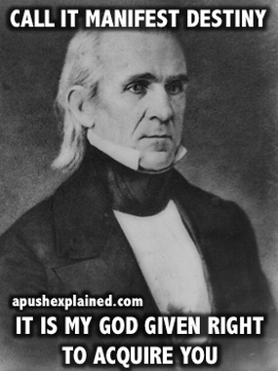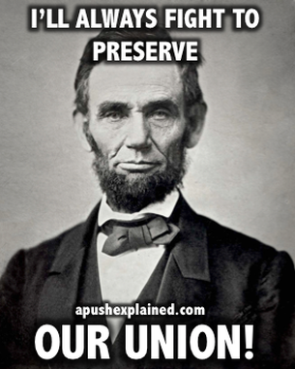

Monday | Tuesday | Wednesday | Thursday |  | Friday
LT:  Antebellum Reformers Speed Dating  HW: Read chapter 12 and complete Study Guide | Period 4 Exam  HW: Read chapter 12 and complete Study Guide | 11/29  LT: Explain the arguments for and against slavery in the Antebellum Period. What role did religion play in those arguments?  Slavery & Antebellum Plantation Society  Writing Wednesday: Short Response  HW: Read chapter 12 and complete Study Guide | 11/30  LT: Identify and analyze the methods of resistance used by slaves.  Slave Narratives  HW: Read chapter 12 and complete Study Guide & Read pages 412-418 |  | 12/1  LT: Identify and analyze the methods of resistance used by slaves  Slave Resistance  Due: Chapter 12 Study Guide & Quiz  HW: Read Chapter 13 Pages 418-428 and complete Chapter 13 Study Guide
12/4  LT: Explain how the idea Manifest Destiny and Westward expansion help create a more perfect union?  Manifest Destiny & Sources on Manifest Destiny  HW: Read Chapter 13 Pages 418-428 and complete Chapter 13 Study Guide | 12/5  **Mrs. Ramirez out on Learning Walks  LT: Explain how the idea Manifest Destiny and Westward expansion help create a more perfect union?  Manifest Destiny & Sources on Manifest Destiny  HW: Read Chapter 13 Pages 418-428 and complete Chapter 13 Study Guide | 12/6  LT: Explain and analyze the extent to which the Mexican-American War justifiable in order to maintain a more perfect union.  Writing Wednesday  Writing: DBQ HIPP. Mexican-American War Debate  HW: Read Chapter 13 Pages 418-428 and complete Chapter 13 Study Guide | 12/7  **Counselor visit: Period 5  LT: Explain and analyze the extent to which the Mexican-American War justifiable in order to maintain a more perfect union.  Writing: DBQ HIPP. Mexican-American War Debate  HW: Read Chapter 13 Pages 428-440 and complete Chapter 13 Study Guide |  | 12/8  **Counselor visits Periods 2 & 3  LT: Explain and analyze the extent to which the Mexican-American War justifiable in order to maintain a more perfect union.  Writing: DBQ HIPP. Mexican-American War Debate  HW: Read Chapter 13 Pages 428-440 and complete Chapter 13 Study Guide
12/11  LT: Explain how the idea of a more perfect union was threatened in the 1850s.  Road to Civil War Note Guide/Lecture  HW: Read Chapter 13 Pages 428-440 and complete Chapter 13 Study Guide | 12/12  LT: Explain how the idea of a more perfect union was threatened in the 1850s.  Short Term Causes of the Civil War  HW: Read Chapter 13 Pages 428-440 and complete Chapter 13 Study Guide | 12/13  LT: Explain how the idea of a more perfect union was threatened in the 1850s.  Chapter 13 Study Guide Due & Ch. 13 Quiz  Causes of Civil War in-class DBQ  HW: Read Chapter 14 and complete Study Guide.  Type up DBQ: Due: Wednesday, December 20. Typed, 12pt. font, double-spaced. | 12/14  LT: Identify the arguments for and against secession and how these ideas challenged our democracy.  Civil War Lecture  Sources on Secession  HW: Read Chapter 14 and complete Study Guide  HW: Read Chapter 14 and complete Study Guide |  | 12/15  LT: Identify the arguments for and against secession and how these ideas challenged our democracy.  Sources on Secession  HW: Read Chapter 14 and complete Study Guide  HW: Read Chapter 14 and complete Study Guide
12/18  LT: Identify the arguments for and against secession and how these ideas challenged our democracy.  Secession Debate  HW: Read Chapter 14 and complete Study Guide | 12/19  LT: Identify Lincoln’s views on democracy explain his arguments for maintaining the union.  Sources on Lincoln  HW: Read Chapter 14 and complete Study Guide | 12/20  LT: Identify Lincoln’s views on democracy explain his arguments for maintaining the union.  Sources on Lincoln  Writing Wednesday  Due: Causes of Civil War DBQ  HW: Read Chapter 14 and complete Study Guide | 12/21  LT: Review for Take Home Exam  KAHOOT REVIEW!!!  Kareoke Madness  Eulogy Selections  HW: Read Chapter 14 and complete Study Guide & Take Home Exam via Google Classroom |  | 12/22  VACATION BEGINS!!  WOO!! WOO!!  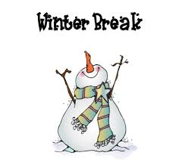
1/8  LT: Explain how Reconstruction sought to restore our union.  Due: Study Guide Due & Chapter 14 Quiz  Reconstruction Lecture  Sources on Reconstruction  HW: Read Chapter 15 and complete Study Guide | 1/9  LT: Explain how Reconstruction sought to restore our union.  Sources on Reconstruction & Reconstruction Simulation Preparation  HW: Read Chapter 15 and complete Study Guide | 1/10  LT: Explain how Reconstruction sought to restore our union.  HW: Read Chapter 15 and complete Study Guide | 1/11  LT: Explain how Reconstruction sought to restore our union.  Sharecropping  HW: Read Chapter 15 and complete Study Guide |  | 1/12  LT: Explain how Reconstruction sought to restore our union.  13th Documentary  HW: Review for Final Exam
1/15  NO SCHOOL  MLK DAY  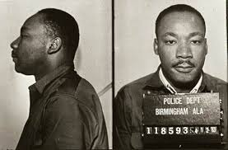 | 1/16  LT: Review for Unit 5 Exam  Due: Chapter 15 Study Guide  Kahoot Review  DBQ Review/Prep  HW: Prepare of Eulogy | 1/17  Period 5 Exam (Chapters 12-15)  HW: Prepare of Eulogy & Read Chapter 16 and Complete Study Guide |  | 1/18  Writing Wednesday: Reconstruction DBQ  HW: Read Chapter 16 and Complete Study Guide  Makeup Exam Day: MC Test and/or DBQ |  | 1/19  LT: Identify Lincoln’s views on democracy explain his arguments for maintaining the union.  Lincoln Memorial Service  HW: Read Chapter 16 and Complete Study Guide

