Silent Spring
Rachel Carson

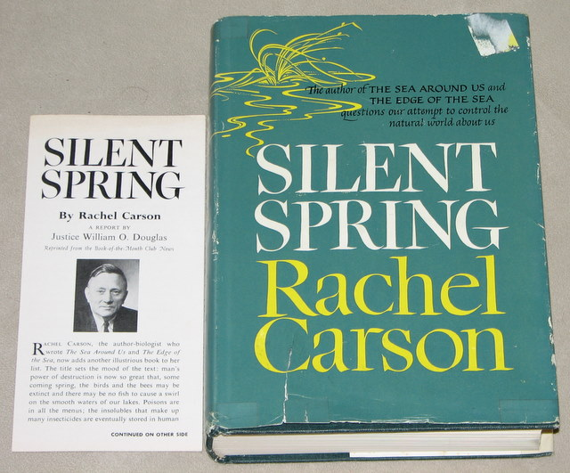

The history of life on earth has been a history of interaction between living things and their surroundings. To a large extent, the physical form and the habits of the earth's vegetation and its animal life have been molded by the environment. Considering the whole span of earthly time, the opposite effect, in which life actually modifies its surroundings, has been relatively slight. Only within the moment of time represented by the present century has one species - man - acquired significant power to alter the nature of his world.

During the past quarter century this power has not only increased to one of disturbing magnitude but it has changed in character. The most alarming of all man's assaults upon the environment is the contamination of air, earth, rivers, and sea with dangerous and even lethal materials. This pollution is for the most part irrecoverable; the chain of evil it initiates not only in the world that must support life but in living tissues is for the most part irreversible. In this now universal contamination of the environment, chemicals are the sinister and little-recognized partners of radiation in changing the very nature of the world - the very nature of its life....

To adjust to these chemicals would require time on the scale that is nature's; it would require not merely the years of a man's life but the life of generations. And even this, were it by some miracle possible, would be futile, for the new chemicals come from our laboratories in an endless stream....

Among them are many that are used in man's war against nature. Since the mid-1940's over 200 basic chemicals have been created for use in killing insects, weeds, rodents, and other organisms described in the modern vernacular as "pests"; and they are sold under several thousand different brand names.

These sprays, dusts, and aerosols are now applied almost universally to farms, gardens, forests, and homes - nonselective chemicals that have the power to kill every insect, the "good" and the bad," to still the song of birds and the leaping of fish in the streams, to coat the leaves with a deadly film, and to linger on in the soil - all this though the intended target may be only a few weeds or insects. Can anyone believe it is possible to lay down such a barrage of poisons on the surface of the earth without making it unfit for all life?

Questions
    - What does Carson blame most for harming the environment?
    - Do you agree with Carson that this damage is “irrecoverable”?
    - Why do you think Carson called her book “Silent Spring”?
    - To what extent do you believe that the actions of human beings have an effect on the environment?
    - Is environmentalism an altruistic ideology? Support your answer.

