“Address to the Commonwealth Club of California”
Cesar Chavez, 1984
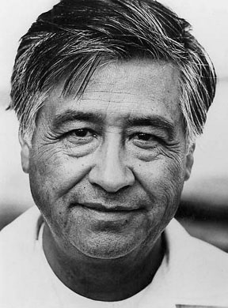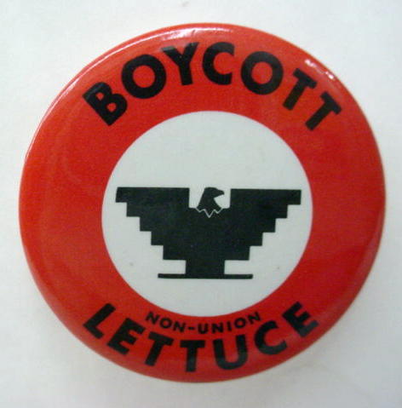
…I began to realize what other minority people had discovered: That the only answer--the only hope--was in organizing. More of us had to become citizens. We had to register to vote. And people like me had to develop the skills it would take to organize, to educate, to help empower the Chicano people.

I spent many years--before we founded the union--learning how to work with people. We experienced some successes in voter registration, in politics, in battling racial discrimination--successes in an era when Black Americans were just beginning to assert their civil rights and when political awareness among Hispanics was almost non-existent…

The growers only have themselves to blame for the humiliation they have brought upon succeeding waves of immigrant groups which have sweated and sacrificed for 100 years to make this industry rich. For generations, they have subjugated entire races of dark-skinned farm workers. These are the sins of the growers, not the farm workers. We didn't poison the land. We didn't open the door to imported produce. We didn't covet billions of dollars in government hand-outs. We didn't abuse and exploit the people who work the land. Today, the growers are like a punch-drunk old boxer who doesn't know he's past his prime. The times are changing…

History and inevitability are on our side. The farm workers and their children--and the Hispanics and their children--are the future in California... Once social change begins, it cannot be reversed. You cannot uneducate the person who has learned to read. You cannot humiliate the person who feels pride. You cannot oppress the people who are not afraid anymore.

Our opponents must understand that it's not just a union we have built. Unions, like other institutions, can come and go. But we're more than an institution. For nearly 20 years, our union has been on the cutting edge of a people's cause--and you cannot do away with an entire people; you cannot stamp out a people's cause.

Regardless of what the future holds for the union, regardless of what the future holds for farm workers, our accomplishments cannot be undone. “La Causa”--our cause--doesn't have to be experienced twice. The consciousness and pride that were raised by our union are alive and thriving inside millions of young Hispanics who will never work on a farm! Like the other immigrant groups, the day will come when we win the economic and political rewards which are in keeping with our numbers in society. The day will come when the politicians do the right thing by our people out of political necessity and not out of charity or idealism. That day may not come this year. That day may not come during this decade. But it will come, someday!

And when that day comes, we shall see the fulfillment of that passage from the Book of Matthew in the New Testament, “That the last shall be first and the first shall be last.”

And on that day, our nation shall fulfill its creed--and that fulfillment shall enrich us all.

Questions
- Background: To what union does Chavez belong? What actions did that union take to advance the rights of Mexican Americans?
- What parallels do you see between Chavez and Martin Luther King?
- What parallels do you see between the farmworker movement of the 1960s-present and the experience of industrial workers in the late 19th and early 20th centuries?
- Why does Chavez believe the triumph of the Hispanic movement is inevitable? Do you agree with his assertion?
- What is the relevance of the Biblical quote at the end of the speech?

