“To the Great White Father and All His People”
by Indians of All Nations,
Occupiers of Alcatraz Island, 1969
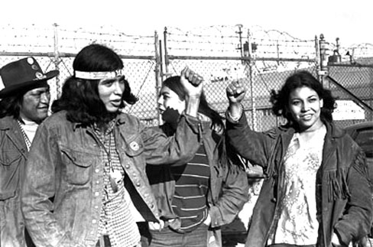

We, the Native Americans, re-claim the land known as Alcatraz Island in the name of all American Indians by right of discovery. . . . We will purchase said Alcatraz Island for twenty-four dollars [$24] in glass beads and red cloth, a precedent set by the white man’s purchase of a similar island [Manhattan] about 300 years ago.

We feel that this so-called Alcatraz Island is more suitable for an Indian Reservation, as determined by the white man’s own standards.

1. It is isolated from modern facilities, and without adequate means of transportation.

2. It has no fresh running water.

3. It has inadequate sanitation facilities.

4. There are no oil or mineral rights.

5. There is no industry and so unemployment is very great.

6. There are no health care facilities.

7. The soil is rocky and non-productive; and the land does not support game [animals].

8. There are no educational facilities.

9. The population has exceeded the land base.

10. The population has always been held prisoners and kept dependent upon others.

Questions
- Background: What were the pros and cons of the federal government’s “termination” policy and movement toward tribal sovereignty for toward Native Americans, beginning in the 1930s and continuing through the 1970s?
- Who do you think is the “great white father” referred to in the title?
- What was the message that American Indian activists wanted to send by occupying Alcatraz Island?
- How would you describe the tone of this “letter”?

